# Tables

##### Table 2.1. Catch (t) for 1991 through 2025 by jurisdiction and gear type (as of 2025-12-8)

|  |  |  |  |  |  |  |  |  |  |  |
| --- | --- | --- | --- | --- | --- | --- | --- | --- | --- | --- |
|  | Federal | | | | | State | | | |  |
| Year | Trawl | Long-line | Pot | Other | Subtot | Long-line | Pot | Other | Subtot | Total |
| 1991 | 58,092 | 7,630 | 10,464 | 115 | 76,301 | - | - | - | - | 76,301 |
| 1992 | 54,593 | 15,675 | 10,154 | 325 | 80,747 | - | - | - | - | 80,747 |
| 1993 | 37,806 | 8,963 | 9,708 | 11 | 56,488 | - | - | - | - | 56,488 |
| 1994 | 31,447 | 6,778 | 9,161 | 100 | 47,486 | - | - | - | - | 47,486 |
| 1995 | 41,875 | 10,978 | 16,055 | 77 | 68,985 | - | - | - | - | 68,985 |
| 1996 | 45,990 | 10,196 | 12,040 | 53 | 68,279 | - | - | - | - | 68,279 |
| 1997 | 48,406 | 10,978 | 9,065 | 26 | 68,475 | - | 7,368 | 1,327 | 8,695 | 77,170 |
| 1998 | 41,570 | 10,012 | 10,510 | 29 | 62,121 | - | 9,183 | 1,320 | 10,503 | 72,624 |
| 1999 | 37,167 | 12,363 | 19,015 | 70 | 68,615 | - | 12,410 | 1,518 | 13,928 | 82,543 |
| 2000 | 25,443 | 11,660 | 17,351 | 54 | 54,508 | - | 10,399 | 1,644 | 12,043 | 66,551 |
| 2001 | 24,383 | 9,910 | 7,171 | 155 | 41,619 | - | 7,829 | 2,083 | 9,912 | 51,531 |
| 2002 | 19,810 | 14,666 | 7,694 | 176 | 42,346 | - | 10,578 | 1,714 | 12,292 | 54,638 |
| 2003 | 18,884 | 9,525 | 12,765 | 161 | 41,335 | 62 | 7,943 | 3,242 | 11,247 | 52,582 |
| 2004 | 17,513 | 10,326 | 14,966 | 400 | 43,205 | 51 | 10,602 | 2,765 | 13,418 | 56,623 |
| 2005 | 14,549 | 5,732 | 14,749 | 203 | 35,233 | 26 | 9,653 | 2,673 | 12,352 | 47,585 |
| 2006 | 13,132 | 10,244 | 14,540 | 118 | 38,034 | 55 | 9,146 | 662 | 9,863 | 47,897 |
| 2007 | 14,775 | 11,539 | 13,573 | 44 | 39,931 | 270 | 11,378 | 682 | 12,330 | 52,261 |
| 2008 | 20,293 | 12,106 | 11,229 | 63 | 43,691 | 317 | 13,438 | 1,568 | 15,323 | 59,014 |
| 2009 | 13,976 | 13,968 | 11,951 | 206 | 40,101 | 676 | 9,919 | 2,500 | 13,095 | 53,196 |
| 2010 | 22,035 | 16,538 | 20,116 | 429 | 59,118 | 826 | 14,604 | 4,045 | 19,475 | 78,593 |
| 2011 | 16,456 | 16,622 | 29,233 | 722 | 63,033 | 1,033 | 16,675 | 4,627 | 22,335 | 85,368 |
| 2012 | 20,084 | 14,467 | 21,238 | 722 | 56,511 | 866 | 15,940 | 4,613 | 21,419 | 77,930 |
| 2013 | 21,706 | 12,836 | 17,011 | 476 | 52,029 | 1,088 | 14,156 | 1,303 | 16,547 | 68,576 |
| 2014 | 26,917 | 14,735 | 19,957 | 1,046 | 62,655 | 1,007 | 18,445 | 2,838 | 22,290 | 84,945 |
| 2015 | 22,268 | 13,047 | 20,653 | 408 | 56,376 | 577 | 19,719 | 2,808 | 23,104 | 79,480 |
| 2016 | 15,217 | 8,123 | 19,248 | 346 | 42,934 | 803 | 18,609 | 1,708 | 21,120 | 64,054 |
| 2017 | 13,041 | 8,965 | 13,426 | 67 | 35,499 | 155 | 13,011 | 62 | 13,228 | 48,727 |
| 2018 | 3,818 | 3,033 | 4,013 | 121 | 10,985 | 310 | 3,660 | 195 | 4,165 | 15,150 |
| 2019 | 4,535 | 2,763 | 3,732 | 178 | 11,208 | 358 | 3,820 | 329 | 4,507 | 15,715 |
| 2020 | 3,427 | 586 | 30 | - | 4,043 | 529 | 1,779 | 491 | 2,799 | 6,842 |
| 2021 | 5,986 | 3,834 | 3,427 | 52 | 13,299 | 558 | 4,230 | 1,085 | 5,873 | 19,172 |
| 2022 | 8,207 | 5,775 | 4,925 | 3 | 18,910 | 357 | 5,645 | 994 | 6,996 | 25,906 |
| 2023 | 6,473 | 5,179 | 4,069 | 378 | 16,099 | 563 | 3,653 | 1,412 | 5,628 | 21,727 |
| 2024 | 8,347 | 5,411 | 5,622 | 319 | 19,699 | 416 | 4,295 | 1,488 | 6,199 | 25,898 |
| 2025 | 8,024 | 4,699 | 6,347 | 533 | 19,603 | 283 | 5,674 | 1,387 | 7,344 | 26,947 |

##### Table 2.2. History of Pacific cod catch (t, includes catch from State waters), Federal TAC (does not include State guideline harvest level, GHL), ABC, OFL and State of Alaska GHL (1997-Present) since 1991. Catch for 2025 is current through 2025-12-8 and includes catch from State of Alaska fisheries. See Hulson et al. 2022 (Table 2.2) for catch history prior to 1991.

|  |  |  |  |  |  |
| --- | --- | --- | --- | --- | --- |
| Year | Catch | TAC | ABC | OFL | GHL |
| 1991 | 76,301 | 77,900 | 77,900 | - | - |
| 1992 | 80,747 | 63,500 | 63,500 | 87,600 | - |
| 1993 | 56,488 | 56,700 | 56,700 | 78,100 | - |
| 1994 | 47,486 | 50,400 | 50,400 | 71,100 | - |
| 1995 | 68,985 | 69,200 | 69,200 | 126,000 | - |
| 1996 | 68,279 | 65,000 | 65,000 | 88,000 | - |
| 1997 | 77,170 | 69,115 | 81,500 | 180,000 | 12,385 |
| 1998 | 72,624 | 66,060 | 77,900 | 141,000 | 11,840 |
| 1999 | 82,543 | 67,835 | 84,400 | 134,000 | 16,565 |
| 2000 | 66,551 | 59,800 | 76,400 | 102,000 | 17,685 |
| 2001 | 51,531 | 52,110 | 67,800 | 91,200 | 15,690 |
| 2002 | 54,638 | 44,230 | 57,600 | 77,100 | 13,370 |
| 2003 | 52,582 | 40,540 | 52,800 | 70,100 | 12,260 |
| 2004 | 56,623 | 48,033 | 62,810 | 102,000 | 14,777 |
| 2005 | 47,585 | 44,433 | 58,100 | 86,200 | 13,667 |
| 2006 | 47,897 | 52,264 | 68,859 | 95,500 | 16,595 |
| 2007 | 52,261 | 52,264 | 68,859 | 97,600 | 16,595 |
| 2008 | 59,014 | 50,269 | 66,493 | 88,660 | 16,224 |
| 2009 | 53,196 | 41,807 | 55,300 | 66,600 | 13,493 |
| 2010 | 78,593 | 59,563 | 79,100 | 94,100 | 19,537 |
| 2011 | 85,368 | 65,100 | 86,800 | 102,600 | 21,700 |
| 2012 | 77,930 | 65,700 | 87,600 | 104,000 | 21,900 |
| 2013 | 68,576 | 60,600 | 80,800 | 97,200 | 20,200 |
| 2014 | 84,945 | 64,738 | 88,500 | 107,300 | 23,762 |
| 2015 | 79,480 | 75,202 | 102,850 | 140,300 | 27,648 |
| 2016 | 64,054 | 71,925 | 98,600 | 116,700 | 26,675 |
| 2017 | 48,727 | 64,442 | 88,342 | 105,378 | 23,900 |
| 2018 | 15,150 | 13,096 | 18,000 | 23,565 | 4,904 |
| 2019 | 15,715 | 12,368 | 17,000 | 23,669 | 4,632 |
| 2020 | 6,842 | 6,431 | 14,621 | 17,794 | 2,537 |
| 2021 | 19,172 | 17,321 | 23,627 | 28,977 | 6,306 |
| 2022 | 25,906 | 24,111 | 32,811 | 39,555 | 8,700 |
| 2023 | 21,727 | 18,103 | 24,634 | 29,737 | 6,531 |
| 2024 | 25,898 | 23,766 | 32,272 | 38,712 | 8,506 |
| 2025 | 26,947 | 23,670 | 32,141 | 38,688 | 8,471 |

##### Table 2.3. History of GOA Pacific cod allocations by regulatory area (in percent) for 1991-2025, and proposed for 2026 (in parentheses). See Barbeaux *et al.* (2018) for 1977-1990.

|  |  |  |  |
| --- | --- | --- | --- |
| Year(s) | Western | Central | Eastern |
| 1991 | 33 | 62 | 5 |
| 1992 | 37 | 61 | 2 |
| 1993-1994 | 33 | 62 | 5 |
| 1995-1996 | 29 | 66 | 5 |
| 1997-1999 | 35 | 63 | 2 |
| 2000-2001 | 36 | 57 | 7 |
| 2002 | 39 | 55 | 6 |
| 2002 | 38 | 56 | 6 |
| 2003 | 39 | 55 | 6 |
| 2003 | 38 | 56 | 6 |
| 2004 | 36 | 57 | 7 |
| 2004 | 35.3 | 56.5 | 8.2 |
| 2005 | 36 | 57 | 7 |
| 2005 | 35.3 | 56.5 | 8.2 |
| 2006 | 39 | 55 | 6 |
| 2006 | 38.54 | 54.35 | 7.11 |
| 2007 | 39 | 55 | 6 |
| 2007 | 38.54 | 54.35 | 7.11 |
| 2008 | 39 | 57 | 4 |
| 2008 | 38.69 | 56.55 | 4.76 |
| 2009 | 39 | 57 | 4 |
| 2009 | 38.69 | 56.55 | 4.76 |
| 2010 | 35 | 62 | 3 |
| 2010 | 34.86 | 61.75 | 3.39 |
| 2011 | 35 | 62 | 3 |
| 2011 | 35 | 62 | 3 |
| 2012 | 35 | 62 | 3 |
| 2012 | 32 | 65 | 3 |
| 2013 | 38 | 60 | 3 |
| 2014 | 37 | 60 | 3 |
| 2015 | 38 | 60 | 3 |
| 2016 | 41 | 50 | 9 |
| 2017 | 41 | 50 | 9 |
| 2018 | 44.9 | 45.1 | 10 |
| 2019 | 44.9 | 45.1 | 10 |
| 2020 | 33.8 | 57.8 | 8.4 |
| 2021 | 33.8 | 57.8 | 8.4 |
| 2022 | 30.3 | 60.2 | 9.5 |
| 2023 | 30.3 | 60.2 | 9.5 |
| 2024 | 27.1 | 63.8 | 9.1 |
| 2025 | 27.1 | 63.8 | 9.1 |
| *2026* | *24.8* | *69.2* | *6* |

##### Table 2.4. Estimated retained and discarded GOA Pacific cod (t, as of 2025-12-8)

|  |  |  |  |
| --- | --- | --- | --- |
| Year | Discarded | Retained | Total |
| 1991 | 1,427 | 74,873 | 76,300 |
| 1992 | 3,920 | 76,827 | 80,747 |
| 1993 | 5,886 | 50,602 | 56,488 |
| 1994 | 3,122 | 44,363 | 47,485 |
| 1995 | 3,546 | 65,439 | 68,985 |
| 1996 | 7,555 | 60,725 | 68,280 |
| 1997 | 4,828 | 72,342 | 77,170 |
| 1998 | 1,732 | 70,893 | 72,625 |
| 1999 | 1,645 | 80,898 | 82,543 |
| 2000 | 1,378 | 65,174 | 66,552 |
| 2001 | 1,904 | 49,627 | 51,531 |
| 2002 | 3,715 | 50,923 | 54,638 |
| 2003 | 2,485 | 50,097 | 52,582 |
| 2004 | 1,268 | 55,355 | 56,623 |
| 2005 | 1,043 | 46,541 | 47,584 |
| 2006 | 1,852 | 46,045 | 47,897 |
| 2007 | 1,448 | 50,813 | 52,261 |
| 2008 | 3,307 | 55,707 | 59,014 |
| 2009 | 3,944 | 49,252 | 53,196 |
| 2010 | 3,097 | 75,496 | 78,593 |
| 2011 | 2,178 | 83,189 | 85,367 |
| 2012 | 949 | 76,981 | 77,930 |
| 2013 | 4,560 | 64,016 | 68,576 |
| 2014 | 5,302 | 79,643 | 84,945 |
| 2015 | 1,723 | 77,758 | 79,481 |
| 2016 | 868 | 63,187 | 64,055 |
| 2017 | 711 | 48,016 | 48,727 |
| 2018 | 604 | 14,546 | 15,150 |
| 2019 | 1,194 | 14,522 | 15,716 |
| 2020 | 1,748 | 5,094 | 6,842 |
| 2021 | 1,404 | 17,769 | 19,173 |
| 2022 | 1,676 | 24,231 | 25,907 |
| 2023 | 1,875 | 19,852 | 21,727 |
| 2024 | 1,607 | 24,292 | 25,899 |
| 2025 | 1,881 | 25,065 | 26,946 |

##### Table 2.5. GOA AFSC Longline survey estimated Relative Population Numbers (RPNs), and bottom trawl survey estimated biomass (t) and numbers of fish (‘Abundance’, in 1000s) shown along with coefficients of variation (in parentheses).

|  |  |  |  |
| --- | --- | --- | --- |
| Year | RPN | Biomass (t) | Abundance |
| 1990 | 116,434 (13.9%) | 413,281 (15.4%) | 210,924 (20.9%) |
| 1991 | 110,061 (14.1%) | - | - |
| 1992 | 136,383 (8.7%) | - | - |
| 1993 | 153,950 (11.4%) | 400,054 (18.1%) | 220,342 (19.5%) |
| 1994 | 96,563 (9.4%) | - | - |
| 1995 | 120,710 (10%) | - | - |
| 1996 | 84,535 (14.1%) | 529,762 (20.3%) | 314,572 (21.8%) |
| 1997 | 104,647 (16.9%) | - | - |
| 1998 | 125,877 (11.5%) | - | - |
| 1999 | 91,480 (11.3%) | 301,719 (12.7%) | 163,498 (11.3%) |
| 2000 | 54,316 (14.5%) | - | - |
| 2001 | 33,841 (18.1%) | 248,745 (20.6%) | 155,231 (18.2%) |
| 2002 | 51,903 (17%) | - | - |
| 2003 | 59,952 (15%) | 295,423 (15.1%) | 158,613 (13%) |
| 2004 | 53,109 (11.8%) | - | - |
| 2005 | 29,864 (21.4%) | 302,673 (26.9%) | 129,306 (21.6%) |
| 2006 | 34,316 (19.7%) | - | - |
| 2007 | 34,994 (14%) | 230,056 (14%) | 190,831 (17.6%) |
| 2008 | 26,881 (22.8%) | - | - |
| 2009 | 68,395 (13.8%) | 741,101 (30.8%) | 562,698 (29.1%) |
| 2010 | 86,725 (13.8%) | - | - |
| 2011 | 93,743 (14.1%) | 492,596 (13.8%) | 342,900 (17.9%) |
| 2012 | 63,768 (14.8%) | - | - |
| 2013 | 48,553 (16.2%) | 502,892 (14.8%) | 336,182 (15.2%) |
| 2014 | 69,665 (14.3%) | - | - |
| 2015 | 88,482 (15.9%) | 248,178 (10.6%) | 193,019 (12.1%) |
| 2016 | 83,887 (17.2%) | - | - |
| 2017 | 39,575 (10.1%) | 103,258 (12.7%) | 54,264 (11.7%) |
| 2018 | 23,857 (12.1%) | - | - |
| 2019 | 14,933 (18.5%) | 179,860 (21.6%) | 124,806 (24.7%) |
| 2020 | 19,459 (21.8%) | - | - |
| 2021 | 30,830 (16.2%) | 172,568 (8.9%) | 89,939 (8.7%) |
| 2022 | 23,393 (15.9%) | - | - |
| 2023 | 30,802 (20.9%) | 222,473 (12.6%) | 125,571 (9.9%) |
| 2025 | 29,233 (18.5%) | 309,761 (23.4%) | 187,845 (23.3%) |

##### Table 2.6. Key parameter estimates with standard deviations (SD) estimated from the author’s recommended model.

|  |  |  |
| --- | --- | --- |
| Name | Value | SD |
| Biology | -- | -- |
| Beginning of year length at age-1 (cm) | 17.64 | 0.303 |
| Beginning of year length at age-10 (cm) | 99.46 | 0.015 |
| Growth rate | 0.19 | 0.002 |
| SD in length-at-age for age-1 | 4.01 | 0.182 |
| SD in length-at-age for age-10 | 9.1 | 0.347 |
| Natural mortality (2014-2016) | 0.84 | 0.053 |
| Natural mortality (all years) | 0.5 | 0.023 |
| Recruitment/Abundance | -- | -- |
| log(mean recruitment) | 13.09 | 0.21 |
| 1976 Regime adjustment | -0.67 | 0.19 |
| Survey catchability | -- | -- |
| Bottom trawl survey | 1.28 | 0.123 |
| Longline survey | 1.17 | 0.108 |
| Longline survey environmental coefficient | 0.95 | 0.397 |

##### Table 2.7. Estimated female spawning biomass (t), standard deviation in spawning biomass (SD), and total biomass (t, age 0+) from the 2024 accepted assessment (denoted as ‘Previous’) and the author’s recommended model (denoted as ‘Current’).

|  |  |  |  |  |  |  |
| --- | --- | --- | --- | --- | --- | --- |
| Year | Previous Sp.Bio | Previous SD[Sp.Bio] | Previous Tot.Bio. | Current Sp.Bio | Current SD[Sp.Bio] | Current Tot.Bio. |
| 1977 | 82,030 | 18,624 | 263,078 | 81,532 | 18,421 | 261,922 |
| 1978 | 93,526 | 20,289 | 274,934 | 92,738 | 20,019 | 273,698 |
| 1979 | 91,392 | 19,576 | 306,236 | 90,442 | 19,279 | 305,621 |
| 1980 | 86,468 | 18,181 | 367,433 | 85,592 | 17,902 | 366,512 |
| 1981 | 100,306 | 21,344 | 404,096 | 99,580 | 21,044 | 402,120 |
| 1982 | 128,098 | 27,305 | 429,094 | 126,933 | 26,868 | 425,811 |
| 1983 | 138,760 | 29,352 | 464,679 | 137,040 | 28,806 | 459,934 |
| 1984 | 140,462 | 29,869 | 506,907 | 138,207 | 29,239 | 500,761 |
| 1985 | 156,013 | 31,122 | 571,308 | 153,132 | 30,386 | 563,723 |
| 1986 | 185,062 | 32,452 | 643,066 | 181,474 | 31,604 | 634,589 |
| 1987 | 213,389 | 33,340 | 705,665 | 209,168 | 32,386 | 696,611 |
| 1988 | 228,887 | 32,111 | 733,973 | 224,496 | 31,148 | 724,735 |
| 1989 | 243,403 | 30,496 | 738,995 | 238,932 | 29,563 | 730,025 |
| 1990 | 246,430 | 27,784 | 722,469 | 242,038 | 26,936 | 714,093 |
| 1991 | 227,089 | 24,492 | 680,037 | 223,096 | 23,770 | 672,712 |
| 1992 | 207,464 | 21,875 | 646,435 | 203,906 | 21,261 | 640,025 |
| 1993 | 190,501 | 19,878 | 613,356 | 187,434 | 19,357 | 607,742 |
| 1994 | 191,073 | 18,675 | 593,657 | 188,231 | 18,204 | 588,353 |
| 1995 | 193,714 | 17,173 | 562,274 | 191,054 | 16,749 | 557,137 |
| 1996 | 176,600 | 14,814 | 500,923 | 174,157 | 14,443 | 496,225 |
| 1997 | 152,166 | 12,234 | 448,772 | 149,887 | 11,918 | 444,617 |
| 1998 | 125,266 | 10,174 | 401,629 | 123,258 | 9,913 | 397,910 |
| 1999 | 109,867 | 9,138 | 365,436 | 108,093 | 8,911 | 362,078 |
| 2000 | 96,878 | 8,662 | 324,871 | 95,240 | 8,446 | 322,039 |
| 2001 | 88,328 | 8,115 | 306,187 | 86,876 | 7,922 | 304,118 |
| 2002 | 84,006 | 7,558 | 310,405 | 82,753 | 7,388 | 309,067 |
| 2003 | 82,664 | 7,400 | 311,203 | 81,684 | 7,252 | 310,329 |
| 2004 | 88,050 | 7,629 | 302,383 | 87,293 | 7,491 | 301,769 |
| 2005 | 87,817 | 7,438 | 280,139 | 87,188 | 7,305 | 279,496 |
| 2006 | 81,816 | 6,620 | 264,404 | 81,328 | 6,503 | 263,509 |
| 2007 | 72,894 | 5,786 | 261,734 | 72,336 | 5,671 | 260,909 |
| 2008 | 65,126 | 5,343 | 282,345 | 64,363 | 5,225 | 281,842 |
| 2009 | 64,976 | 5,702 | 320,013 | 64,250 | 5,588 | 319,879 |
| 2010 | 82,099 | 7,028 | 370,972 | 81,442 | 6,910 | 371,394 |
| 2011 | 94,676 | 8,458 | 394,847 | 94,092 | 8,337 | 395,909 |
| 2012 | 103,497 | 9,906 | 399,102 | 103,150 | 9,796 | 401,222 |
| 2013 | 110,310 | 11,073 | 414,288 | 110,236 | 10,979 | 418,360 |
| 2014 | 111,288 | 11,831 | 463,262 | 111,680 | 11,770 | 470,503 |
| 2015 | 79,084 | 7,540 | 362,383 | 78,400 | 7,375 | 363,504 |
| 2016 | 62,598 | 5,599 | 255,983 | 61,134 | 5,369 | 252,790 |
| 2017 | 48,276 | 4,390 | 161,564 | 46,249 | 4,128 | 156,551 |
| 2018 | 42,448 | 4,549 | 137,613 | 40,443 | 4,306 | 133,276 |
| 2019 | 41,786 | 4,293 | 146,791 | 39,932 | 4,099 | 143,626 |
| 2020 | 41,907 | 4,216 | 159,919 | 40,298 | 4,072 | 158,719 |
| 2021 | 50,256 | 4,537 | 178,117 | 49,127 | 4,451 | 179,657 |
| 2022 | 55,452 | 4,940 | 180,403 | 55,225 | 4,901 | 186,049 |
| 2023 | 54,246 | 5,070 | 174,394 | 55,298 | 5,036 | 185,759 |
| 2024 | 52,034 | 5,160 | 174,445 | 54,879 | 5,112 | 188,381 |
| 2025 | 46,920 | 5,643 | 177,497 | 54,728 | 5,564 | 185,884 |
| 2026 | - | - | - | 52,772 | 6,247 | 182,156 |

##### Table 2.8. Age-0 recruitment (millions) and standard deviation of age-0 recruits by year from the 2024 accepted assessment (denoted as ‘Previous’) and the author’s recommended model (denoted as ‘Current’). Highlighted are the 1977 and 2012 year classes.

|  |  |  |  |  |
| --- | --- | --- | --- | --- |
| Year | Previous Recruitment | Previous SD[Rec] | Current Recruitment | Current SD[Rec] |
| 1977 | 1.18 | 0.36 | 1.18 | 0.35 |
| 1978 | 0.39 | 0.14 | 0.39 | 0.14 |
| 1979 | 0.37 | 0.13 | 0.36 | 0.13 |
| 1980 | 0.65 | 0.21 | 0.64 | 0.21 |
| 1981 | 0.7 | 0.23 | 0.69 | 0.22 |
| 1982 | 0.94 | 0.3 | 0.93 | 0.3 |
| 1983 | 0.68 | 0.27 | 0.68 | 0.27 |
| 1984 | 0.9 | 0.3 | 0.9 | 0.29 |
| 1985 | 0.88 | 0.25 | 0.88 | 0.25 |
| 1986 | 0.61 | 0.17 | 0.62 | 0.17 |
| 1987 | 0.66 | 0.16 | 0.66 | 0.16 |
| 1988 | 0.66 | 0.16 | 0.66 | 0.16 |
| 1989 | 0.69 | 0.16 | 0.69 | 0.16 |
| 1990 | 0.78 | 0.17 | 0.78 | 0.17 |
| 1991 | 0.57 | 0.13 | 0.58 | 0.13 |
| 1992 | 0.43 | 0.1 | 0.42 | 0.1 |
| 1993 | 0.36 | 0.08 | 0.36 | 0.08 |
| 1994 | 0.42 | 0.09 | 0.42 | 0.09 |
| 1995 | 0.54 | 0.11 | 0.54 | 0.1 |
| 1996 | 0.4 | 0.08 | 0.4 | 0.08 |
| 1997 | 0.36 | 0.07 | 0.37 | 0.07 |
| 1998 | 0.34 | 0.07 | 0.34 | 0.07 |
| 1999 | 0.51 | 0.1 | 0.52 | 0.1 |
| 2000 | 0.5 | 0.1 | 0.5 | 0.1 |
| 2001 | 0.3 | 0.06 | 0.3 | 0.06 |
| 2002 | 0.26 | 0.05 | 0.26 | 0.05 |
| 2003 | 0.3 | 0.06 | 0.3 | 0.06 |
| 2004 | 0.3 | 0.06 | 0.3 | 0.06 |
| 2005 | 0.54 | 0.1 | 0.54 | 0.1 |
| 2006 | 0.74 | 0.13 | 0.74 | 0.13 |
| 2007 | 0.54 | 0.1 | 0.54 | 0.1 |
| 2008 | 0.79 | 0.15 | 0.8 | 0.15 |
| 2009 | 0.43 | 0.09 | 0.44 | 0.09 |
| 2010 | 0.52 | 0.11 | 0.53 | 0.11 |
| 2011 | 0.81 | 0.17 | 0.82 | 0.17 |
| 2012 | 1.18 | 0.27 | 1.21 | 0.28 |
| 2013 | 0.72 | 0.19 | 0.76 | 0.2 |
| 2014 | 0.24 | 0.07 | 0.25 | 0.07 |
| 2015 | 0.28 | 0.07 | 0.29 | 0.08 |
| 2016 | 0.28 | 0.06 | 0.28 | 0.06 |
| 2017 | 0.3 | 0.06 | 0.31 | 0.06 |
| 2018 | 0.21 | 0.04 | 0.23 | 0.05 |
| 2019 | 0.18 | 0.04 | 0.19 | 0.04 |
| 2020 | 0.19 | 0.04 | 0.22 | 0.05 |
| 2021 | 0.22 | 0.05 | 0.27 | 0.06 |
| 2022 | 0.21 | 0.07 | 0.2 | 0.05 |
| 2023 | 0.41 | 0.19 | 0.19 | 0.06 |
| 2024 | 0.49 | 0.24 | 0.3 | 0.1 |
| 2025 | - | - | 0.48 | 0.23 |
| Mean 1977 - (Final year - 2) | 0.52 |  | 0.52 |  |

##### Table 2.9. Estimated fishing mortality in terms of apical F and total exploitation for the author’s recommended model.

|  |  |  |  |
| --- | --- | --- | --- |
| Year | Sum Apical F | SD[F] | Total Exploitation |
| 1977 | 0.012 | 0.003 | 0.009 |
| 1978 | 0.059 | 0.013 | 0.045 |
| 1979 | 0.078 | 0.018 | 0.049 |
| 1980 | 0.194 | 0.046 | 0.096 |
| 1981 | 0.124 | 0.027 | 0.09 |
| 1982 | 0.091 | 0.019 | 0.069 |
| 1983 | 0.117 | 0.025 | 0.079 |
| 1984 | 0.076 | 0.017 | 0.048 |
| 1985 | 0.066 | 0.016 | 0.026 |
| 1986 | 0.096 | 0.023 | 0.039 |
| 1987 | 0.067 | 0.016 | 0.047 |
| 1988 | 0.064 | 0.009 | 0.047 |
| 1989 | 0.08 | 0.012 | 0.059 |
| 1990 | 0.187 | 0.022 | 0.102 |
| 1991 | 0.217 | 0.024 | 0.113 |
| 1992 | 0.253 | 0.028 | 0.126 |
| 1993 | 0.189 | 0.02 | 0.093 |
| 1994 | 0.157 | 0.015 | 0.081 |
| 1995 | 0.234 | 0.021 | 0.124 |
| 1996 | 0.255 | 0.022 | 0.138 |
| 1997 | 0.348 | 0.029 | 0.174 |
| 1998 | 0.404 | 0.035 | 0.183 |
| 1999 | 0.546 | 0.05 | 0.228 |
| 2000 | 0.488 | 0.047 | 0.207 |
| 2001 | 0.395 | 0.038 | 0.169 |
| 2002 | 0.446 | 0.042 | 0.177 |
| 2003 | 0.429 | 0.04 | 0.169 |
| 2004 | 0.439 | 0.039 | 0.188 |
| 2005 | 0.4 | 0.041 | 0.17 |
| 2006 | 0.431 | 0.04 | 0.182 |
| 2007 | 0.493 | 0.042 | 0.2 |
| 2008 | 0.613 | 0.055 | 0.209 |
| 2009 | 0.515 | 0.048 | 0.166 |
| 2010 | 0.608 | 0.056 | 0.212 |
| 2011 | 0.591 | 0.057 | 0.216 |
| 2012 | 0.477 | 0.048 | 0.194 |
| 2013 | 0.39 | 0.041 | 0.164 |
| 2014 | 0.578 | 0.06 | 0.181 |
| 2015 | 0.788 | 0.075 | 0.219 |
| 2016 | 0.815 | 0.073 | 0.253 |
| 2017 | 0.799 | 0.085 | 0.311 |
| 2018 | 0.248 | 0.027 | 0.114 |
| 2019 | 0.255 | 0.027 | 0.109 |
| 2020 | 0.101 | 0.01 | 0.043 |
| 2021 | 0.253 | 0.024 | 0.107 |
| 2022 | 0.313 | 0.029 | 0.139 |
| 2023 | 0.257 | 0.024 | 0.117 |
| 2024 | 0.311 | 0.03 | 0.137 |
| 2025 | 0.399 | 0.043 | 0.173 |

##### Table 2.10. Biological reference points from GOA Pacific cod SAFE documents for years 2002 – 2025, and recommended for 2026 from the author’s recommended model (in italics).

|  |  |  |  |  |  |
| --- | --- | --- | --- | --- | --- |
| Year | SB100% | SB40% | F40% | OFLy+1 | maxABCy+1 |
| 2002 | 212,000 | 85,000 | 0.41 | 82,000 | 57,600 |
| 2003 | 226,000 | 90,300 | 0.35 | 88,300 | 52,800 |
| 2004 | 222,000 | 88,900 | 0.34 | 103,000 | 62,810 |
| 2005 | 211,000 | 84,400 | 0.31 | 91,700 | 58,100 |
| 2006 | 329,000 | 132,000 | 0.56 | 165,000 | 68,859 |
| 2007 | 259,000 | 103,000 | 0.46 | 136,000 | 68,859 |
| 2008 | 302,000 | 121,000 | 0.49 | 108,000 | 66,493 |
| 2009 | 255,500 | 102,200 | 0.52 | 88,000 | 55,300 |
| 2010 | 291,500 | 116,600 | 0.49 | 117,600 | 79,100 |
| 2011 | 256,300 | 102,500 | 0.42 | 124,100 | 86,800 |
| 2012 | 261,000 | 104,000 | 0.44 | 121,000 | 87,600 |
| 2013 | 234,800 | 93,900 | 0.49 | 111,000 | 80,800 |
| 2014 | 227,800 | 91,100 | 0.54 | 120,100 | 88,500 |
| 2015 | 316,500 | 126,600 | 0.5 | 155,400 | 102,850 |
| 2016 | 325,200 | 130,000 | 0.41 | 116,700 | 98,600 |
| 2017 | 196,776 | 78,711 | 0.53 | 105,378 | 88,342 |
| 2018 | 168,583 | 67,433 | 0.34 | 23,565 | 19,401 |
| 2019 | 172,240 | 68,896 | 0.29 | 23,669 | 19,665 |
| 2020 | 187,780 | 75,112 | 0.22 | 17,794 | 14,621 |
| 2021 | 180,111 | 72,045 | 0.33 | 28,977 | 23,627 |
| 2022 | 165,508 | 66,203 | 0.5 | 39,555 | 32,811 |
| 2023 | 167,414 | 66,966 | 0.41 | 29,737 | 24,634 |
| 2024 | 175,187 | 70,075 | 0.42 | 38,712 | 32,272 |
| 2025 | 163,585 | 65,434 | 0.46 | 38,688 | 32,141 |
| *2026* | *159,595* | *63,838* | *0.54* | *49,782* | *41,520* |

##### Table 2.11. Results for the projection scenarios from the author’s recommended model. Catch in tons, fishing mortality (F), and Female spawning stock biomass (SSB) in tons for the 7 standard projection scenarios.

|  |  |  |  |  |  |  |  |
| --- | --- | --- | --- | --- | --- | --- | --- |
| Year | Scenario 1 | Scenario 2 | Scenario 3 | Scenario 4 | Scenario 5 | Scenario 6 | Scenario 7 |
| Catch | - | - | - | - | - | - | - |
| 2025 | 32,141 | 32,141 | 32,141 | 32,141 | 32,141 | 32,141 | 32,141 |
| 2026 | 41,520 | 41,520 | 20,535 | 32,340 | 0 | 49,782 | 41,520 |
| 2027 | 32,209 | 32,209 | 20,887 | 28,434 | 0 | 34,424 | 32,209 |
| 2028 | 32,838 | 32,838 | 22,253 | 29,672 | 0 | 34,899 | 39,691 |
| 2029 | 47,592 | 47,592 | 26,758 | 42,138 | 0 | 51,807 | 53,219 |
| 2030 | 67,740 | 67,740 | 33,569 | 56,137 | 0 | 76,954 | 76,927 |
| 2031 | 75,310 | 75,310 | 39,973 | 64,128 | 0 | 83,998 | 83,896 |
| 2032 | 79,182 | 79,182 | 44,461 | 68,825 | 0 | 86,684 | 86,627 |
| 2033 | 80,798 | 80,798 | 47,200 | 71,138 | 0 | 87,572 | 87,548 |
| 2034 | 81,444 | 81,444 | 48,815 | 72,226 | 0 | 87,858 | 87,849 |
| 2035 | 81,714 | 81,714 | 49,773 | 72,749 | 0 | 87,963 | 87,959 |
| 2036 | 81,813 | 81,813 | 50,278 | 72,972 | 0 | 87,995 | 87,994 |
| 2037 | 81,845 | 81,845 | 50,526 | 73,060 | 0 | 88,003 | 88,003 |
| 2038 | 81,856 | 81,856 | 50,647 | 73,094 | 0 | 88,006 | 88,005 |
| F | - | - | - | - | - | - | - |
| 2025 | 0.4 | 0.4 | 0.4 | 0.4 | 0.4 | 0.4 | 0.4 |
| 2026 | 0.54 | 0.54 | 0.25 | 0.41 | 0 | 0.68 | 0.54 |
| 2027 | 0.47 | 0.47 | 0.25 | 0.38 | 0 | 0.54 | 0.47 |
| 2028 | 0.46 | 0.46 | 0.25 | 0.38 | 0 | 0.53 | 0.57 |
| 2029 | 0.56 | 0.56 | 0.25 | 0.45 | 0 | 0.65 | 0.66 |
| 2030 | 0.66 | 0.66 | 0.25 | 0.5 | 0 | 0.82 | 0.82 |
| 2031 | 0.66 | 0.66 | 0.25 | 0.5 | 0 | 0.83 | 0.83 |
| 2032 | 0.66 | 0.66 | 0.25 | 0.5 | 0 | 0.83 | 0.83 |
| 2033 | 0.66 | 0.66 | 0.25 | 0.5 | 0 | 0.83 | 0.83 |
| 2034 | 0.66 | 0.66 | 0.25 | 0.5 | 0 | 0.83 | 0.83 |
| 2035 | 0.66 | 0.66 | 0.25 | 0.5 | 0 | 0.83 | 0.83 |
| 2036 | 0.66 | 0.66 | 0.25 | 0.5 | 0 | 0.83 | 0.83 |
| 2037 | 0.66 | 0.66 | 0.25 | 0.5 | 0 | 0.83 | 0.83 |
| 2038 | 0.66 | 0.66 | 0.25 | 0.5 | 0 | 0.83 | 0.83 |
| SSB | - | - | - | - | - | - | - |
| 2025 | 54,728 | 54,728 | 54,728 | 54,728 | 54,728 | 54,728 | 54,728 |
| 2026 | 52,772 | 52,772 | 52,772 | 52,772 | 52,772 | 52,772 | 52,772 |
| 2027 | 45,838 | 45,838 | 53,440 | 49,137 | 61,074 | 42,910 | 45,838 |
| 2028 | 45,359 | 45,359 | 55,636 | 49,387 | 69,692 | 42,204 | 45,359 |
| 2029 | 54,298 | 54,298 | 65,974 | 58,499 | 85,168 | 51,177 | 52,016 |
| 2030 | 67,138 | 67,138 | 83,250 | 72,180 | 107,920 | 63,374 | 63,394 |
| 2031 | 75,512 | 75,512 | 100,185 | 83,416 | 131,896 | 69,498 | 69,418 |
| 2032 | 80,051 | 80,051 | 112,440 | 90,336 | 151,858 | 72,201 | 72,148 |
| 2033 | 82,043 | 82,043 | 120,216 | 93,903 | 167,166 | 73,152 | 73,128 |
| 2034 | 82,878 | 82,878 | 125,016 | 95,662 | 178,886 | 73,476 | 73,466 |
| 2035 | 83,245 | 83,245 | 127,988 | 96,548 | 187,781 | 73,600 | 73,596 |
| 2036 | 83,382 | 83,382 | 129,578 | 96,932 | 193,586 | 73,639 | 73,638 |
| 2037 | 83,426 | 83,426 | 130,359 | 97,082 | 197,123 | 73,649 | 73,648 |
| 2038 | 83,442 | 83,442 | 130,742 | 97,141 | 199,278 | 73,652 | 73,652 |

# Figures

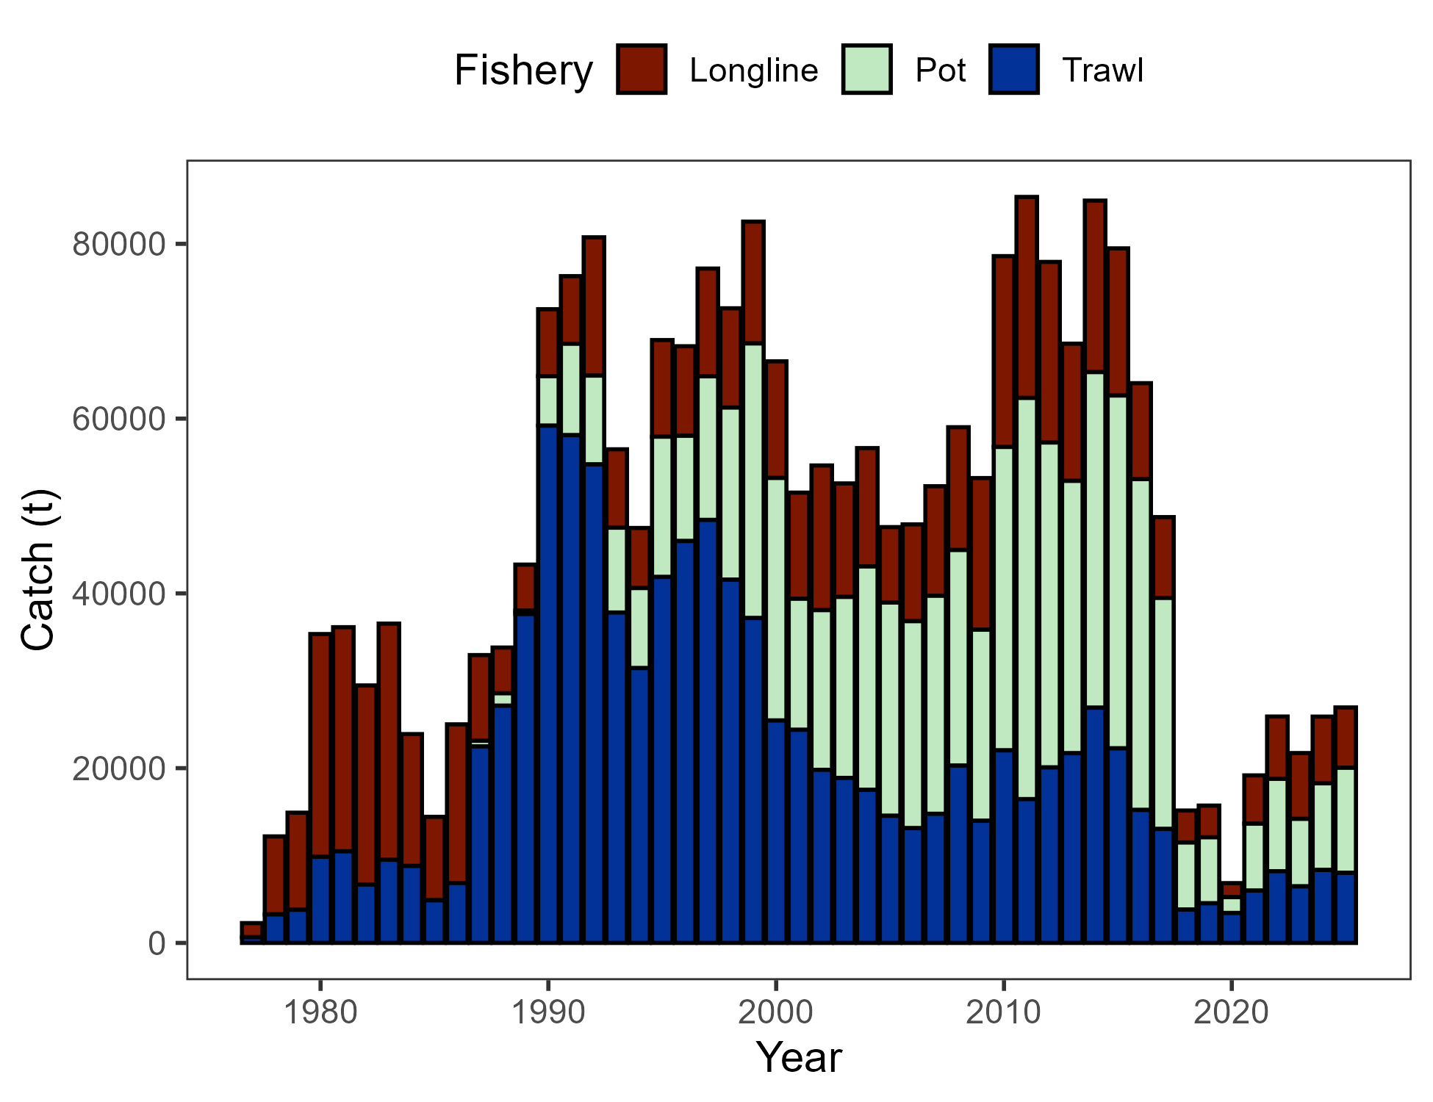

##### Figure 2.1. Commercial catch (mt) of Pacific cod in the GOA in trawl (FshTrawl), longline (FshLL), and pot (FshPot) gear from 1977-2025. Note that 2025 catch was through December 8.

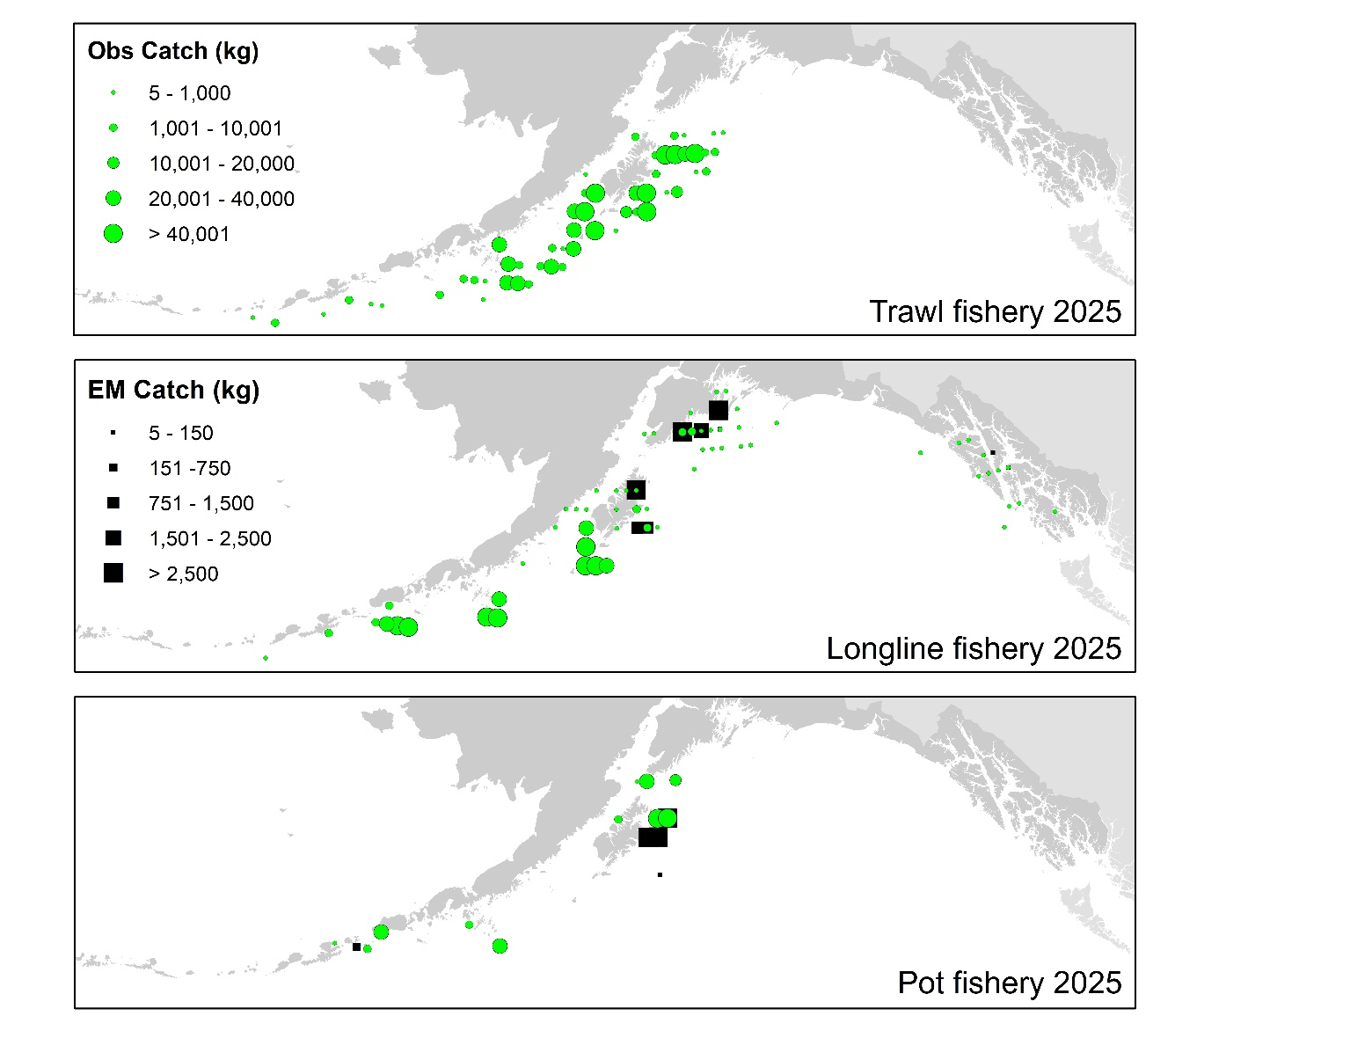

##### Figure 2.2. Observed (Obs) and electronic monitored (EM) commercial catch of Pacific cod in the GOA by 20 km2 grid for 2025. These data include bycatch Pacific cod, but do not include trawl EM data as locations are not yet available.

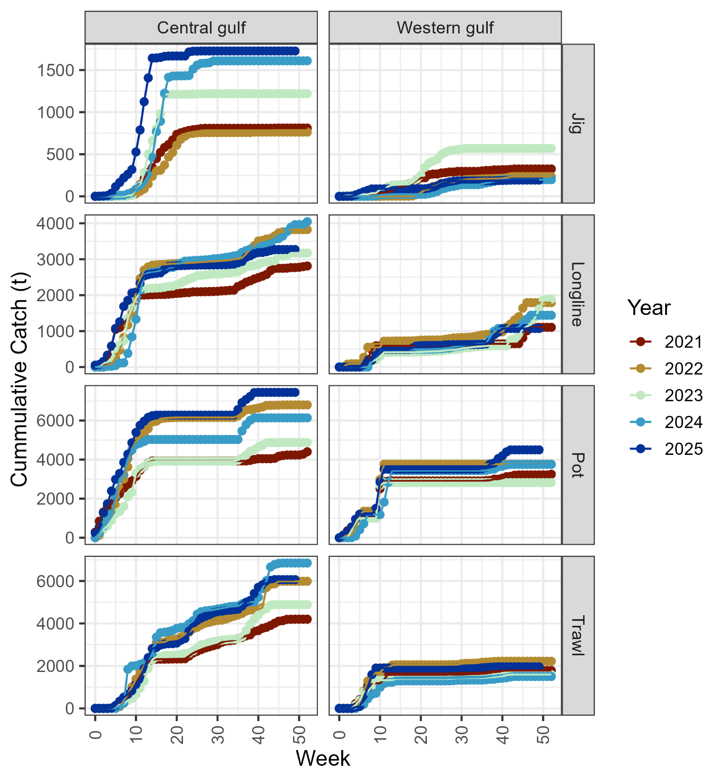

##### Figure 2.3. Cumulative catch week of the year for 2021-2025 by GOA sub-area and fleet (2025 catch through December 8).

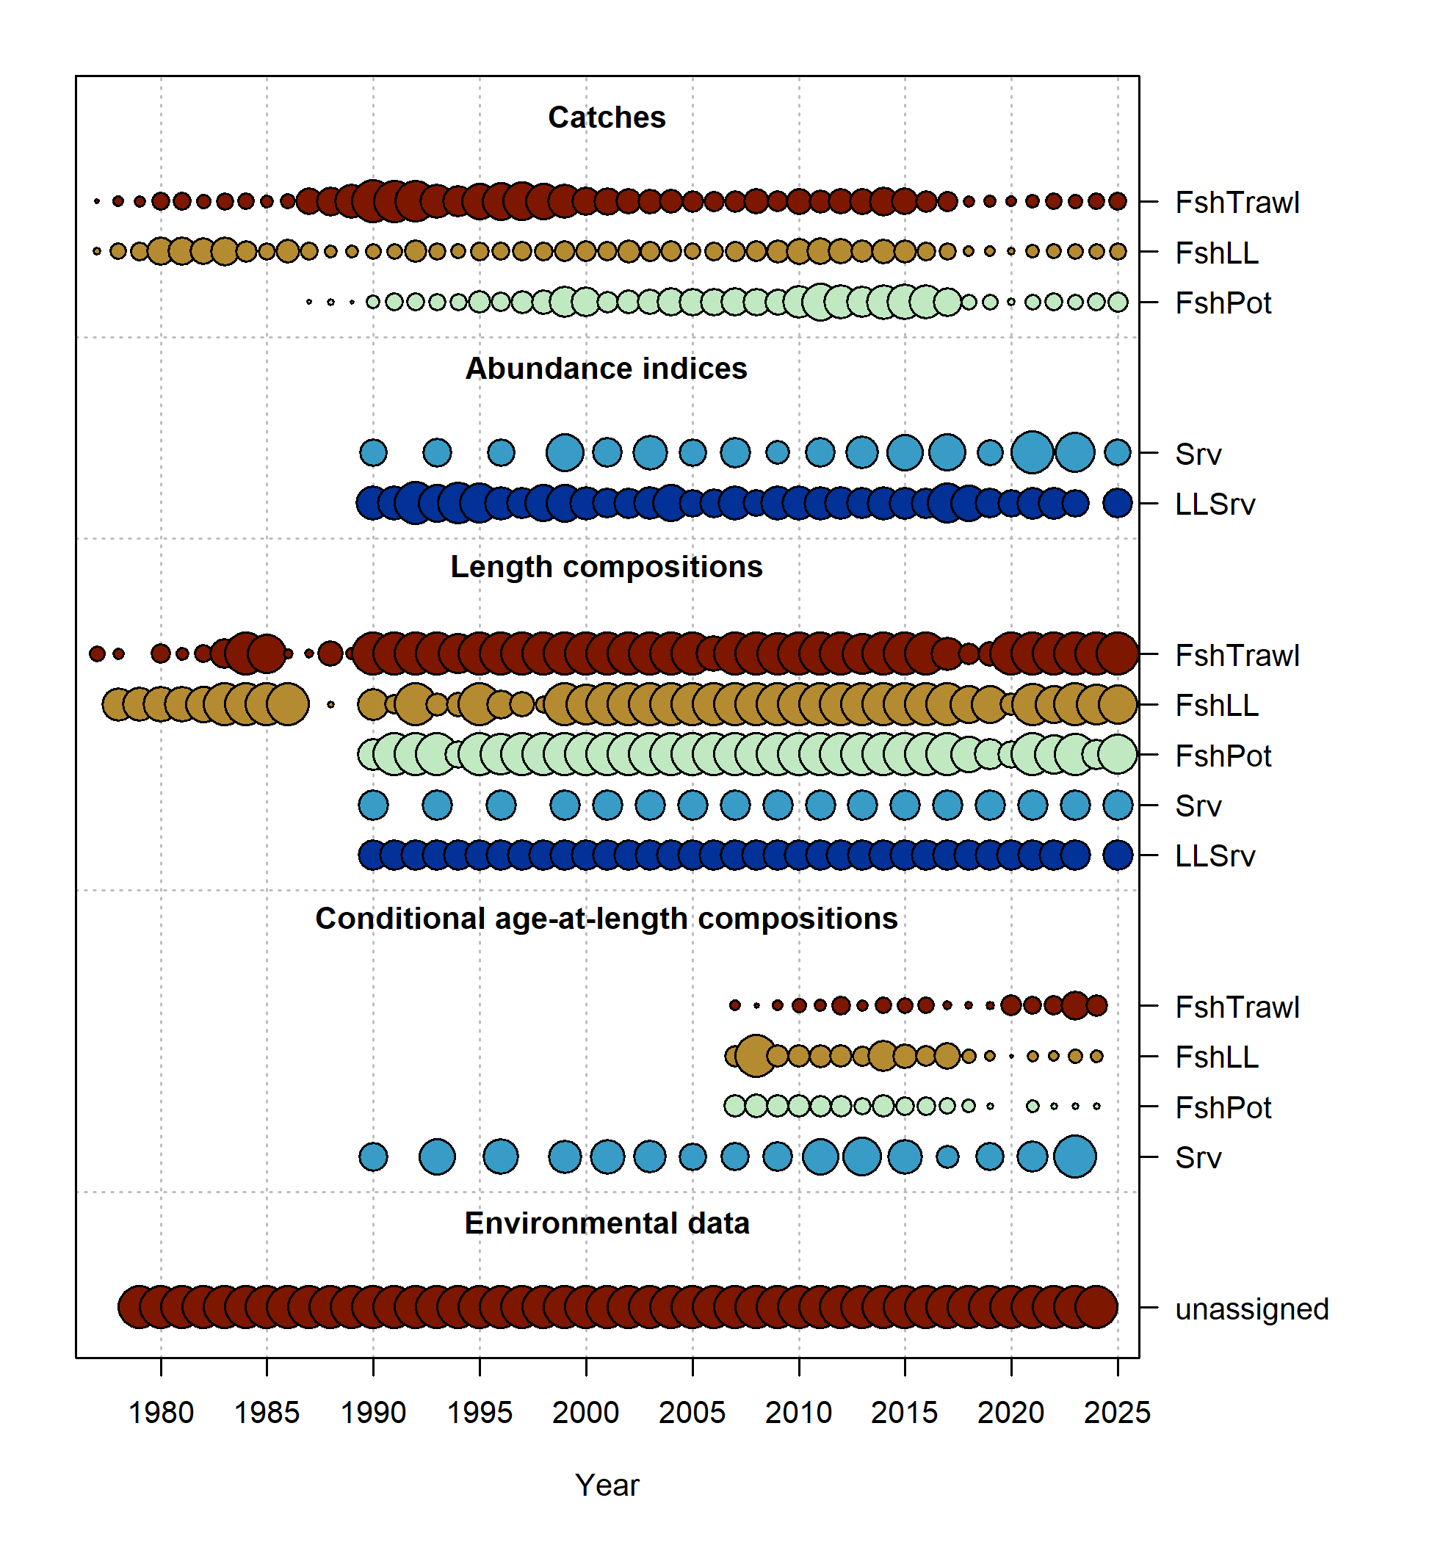

##### Figure 2.4. Data fit in Model 24.0. Circles are proportional to total catch for catches, precision for indices and input sample size for compositions and length-at-age observations. Data source include fishery data from trawl (FshTrawl), longline (FshLL), and pot (FshPot) fisheries. Survey data include the AFSC longline (LLSrv) and bottom trawl (Srv) surveys. Note that since the circles are scaled relative to maximum within each type, the plots of scaling across dataset types should not be compared.

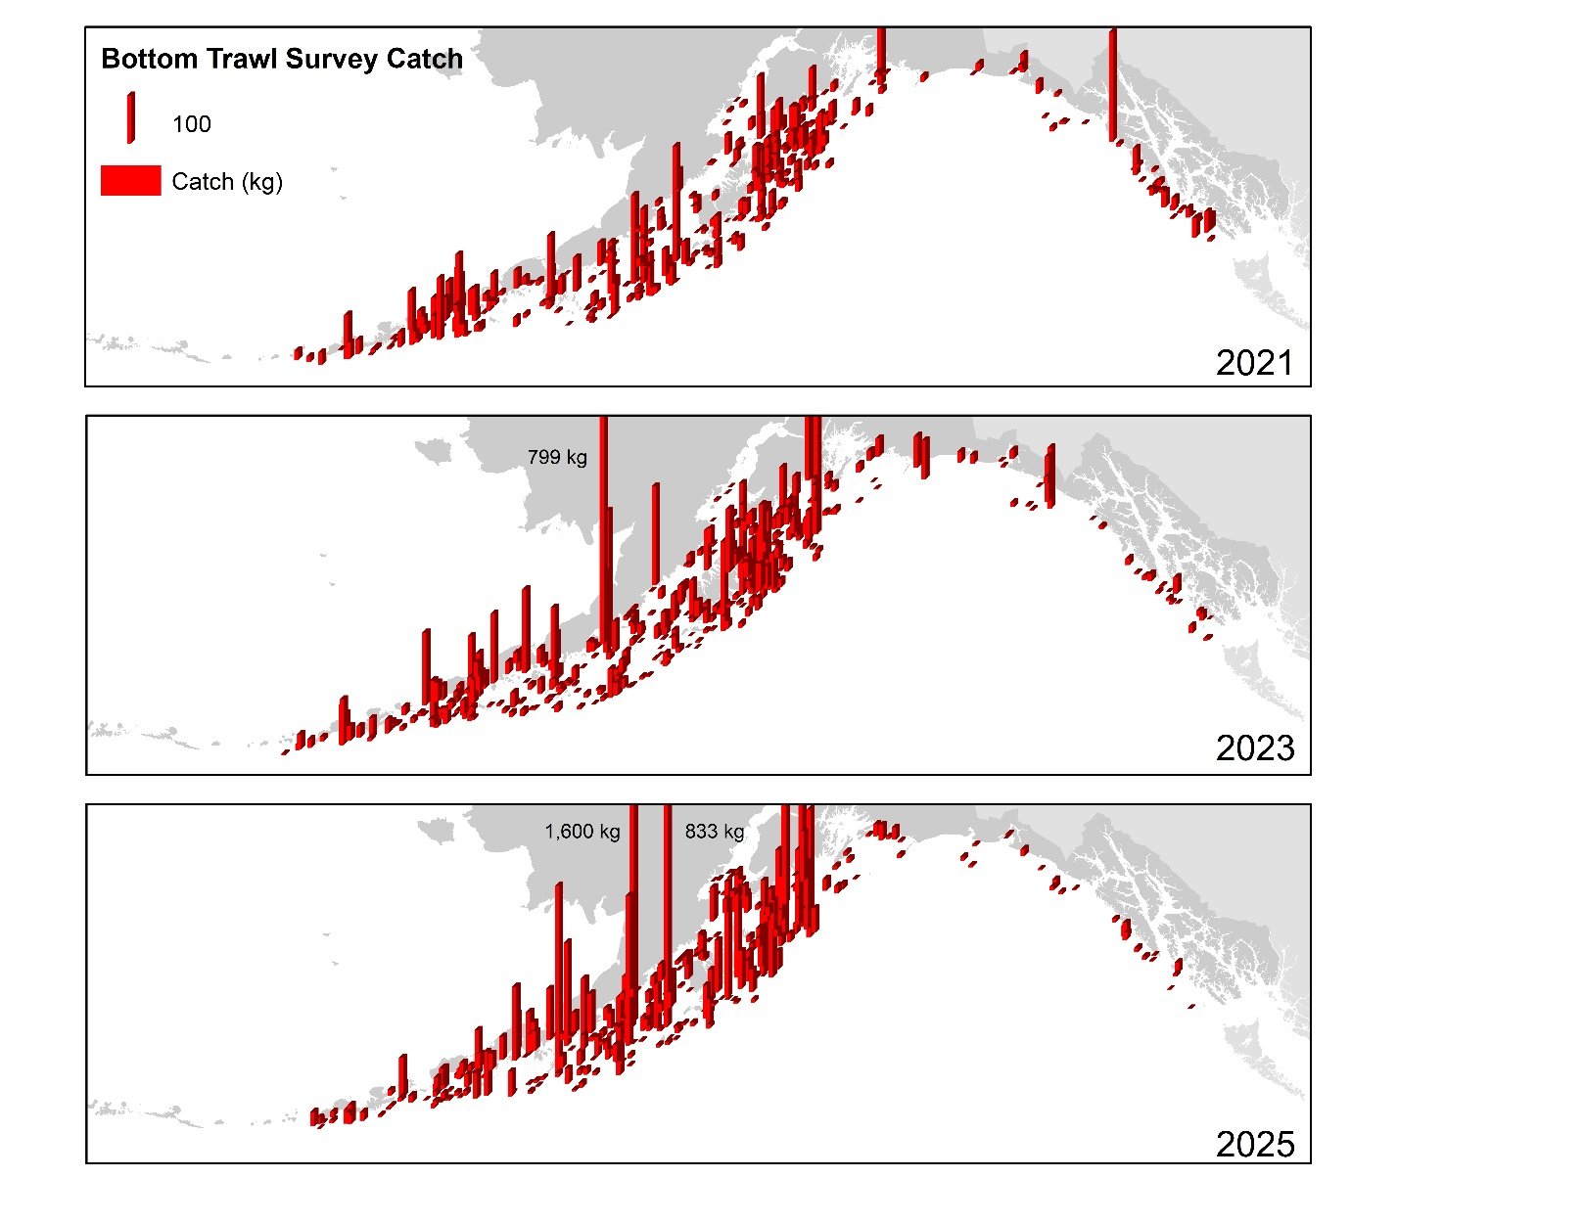

##### Figure 2.5. Distribution of AFSC bottom trawl survey catch (kg) of Pacific cod for 2021-2025.

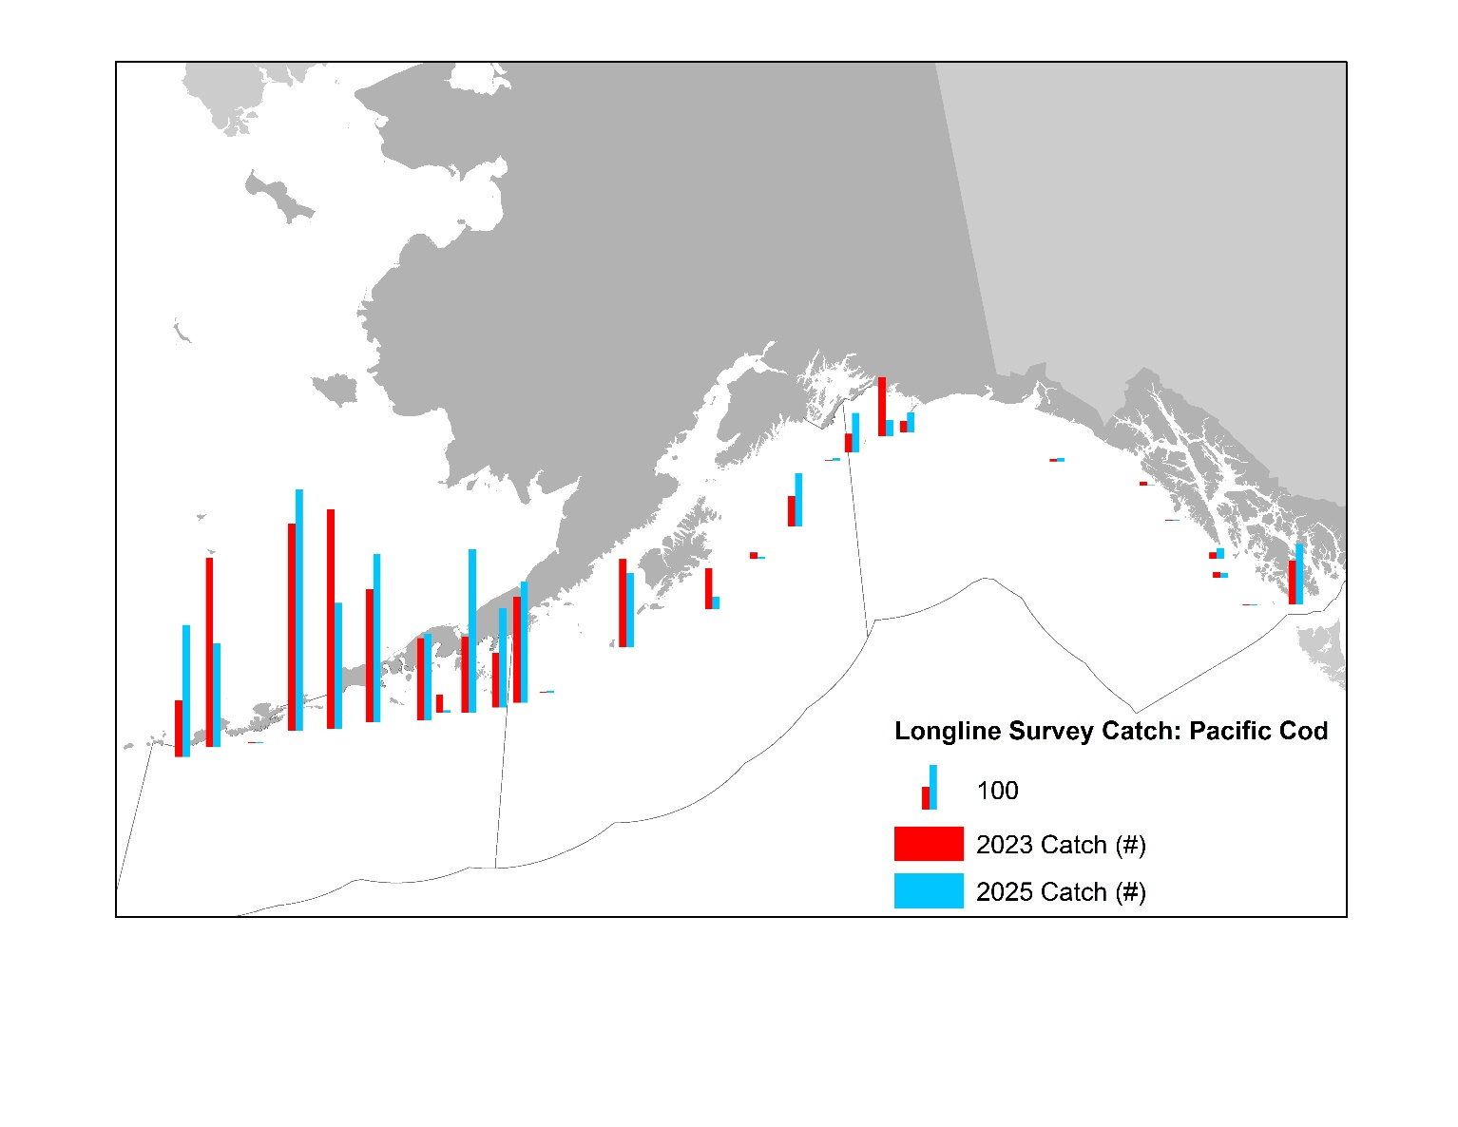

##### Figure 2.6. Distribution of AFSC longline survey catch (numbers) of Pacific cod in 2023 and 2025.

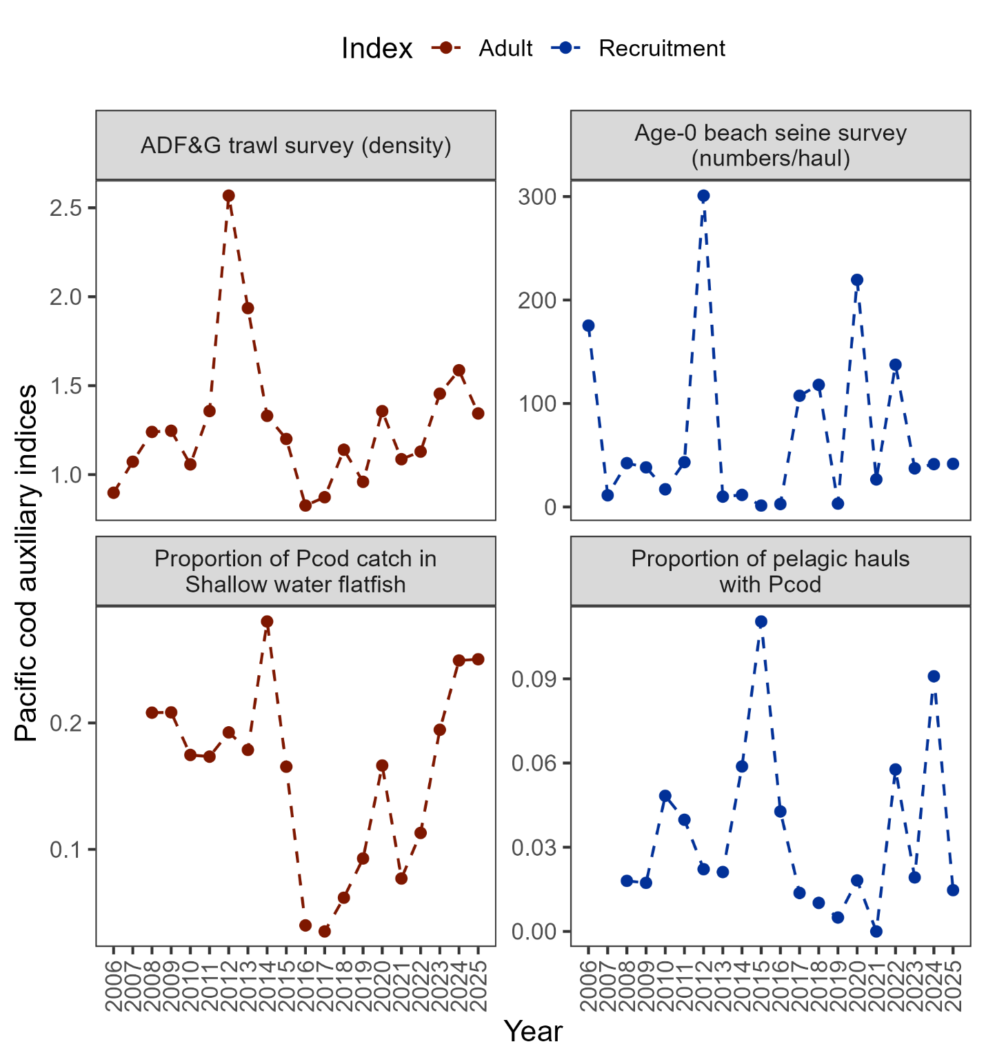

##### Figure 2.7. Auxiliary indices for GOA Pacific cod adult and recruitment abundance. ADFG bottom trawl survey delta-glm density (top left panel) and proportion of Pacific cod bycatch in the GOA shallow water flatfish fishery (bottom left panel) representing indices for adult abundance, and age-0 beach seine survey numbers per haul (top right panel) and proportion of pelagic trawls in the Central GOA A Season (January-April) walleye pollock fishery with Pacific cod present (bottom right panel) representing indices for recruitment.

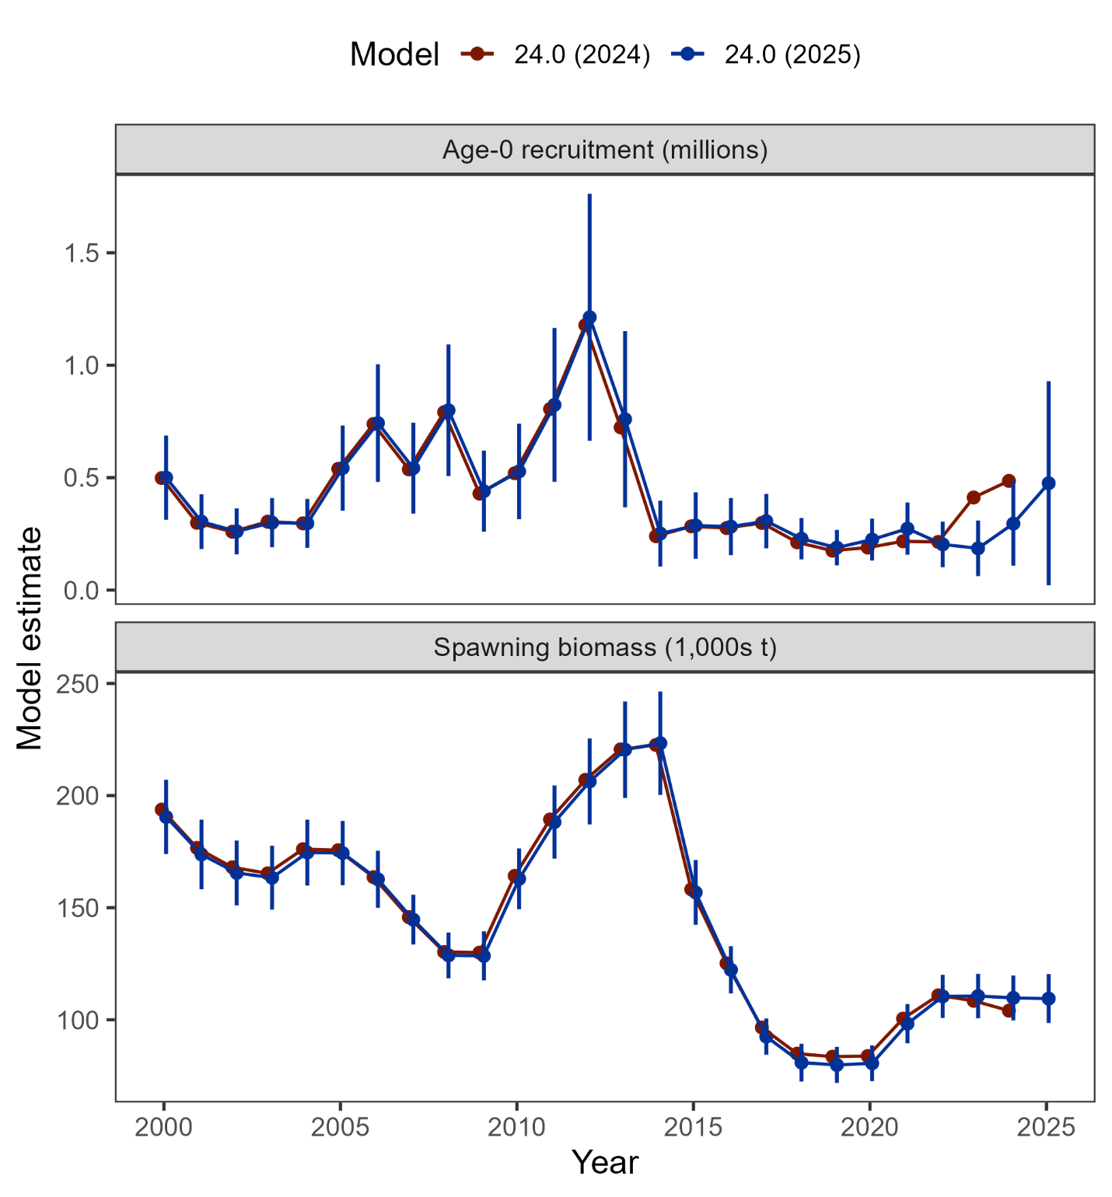

##### Figure 2.8. Comparison of recruitment and spawning biomass estimated from Model 24.0 as applied in 2024 and with updated data in 2025 (including 95% confidence intervals).

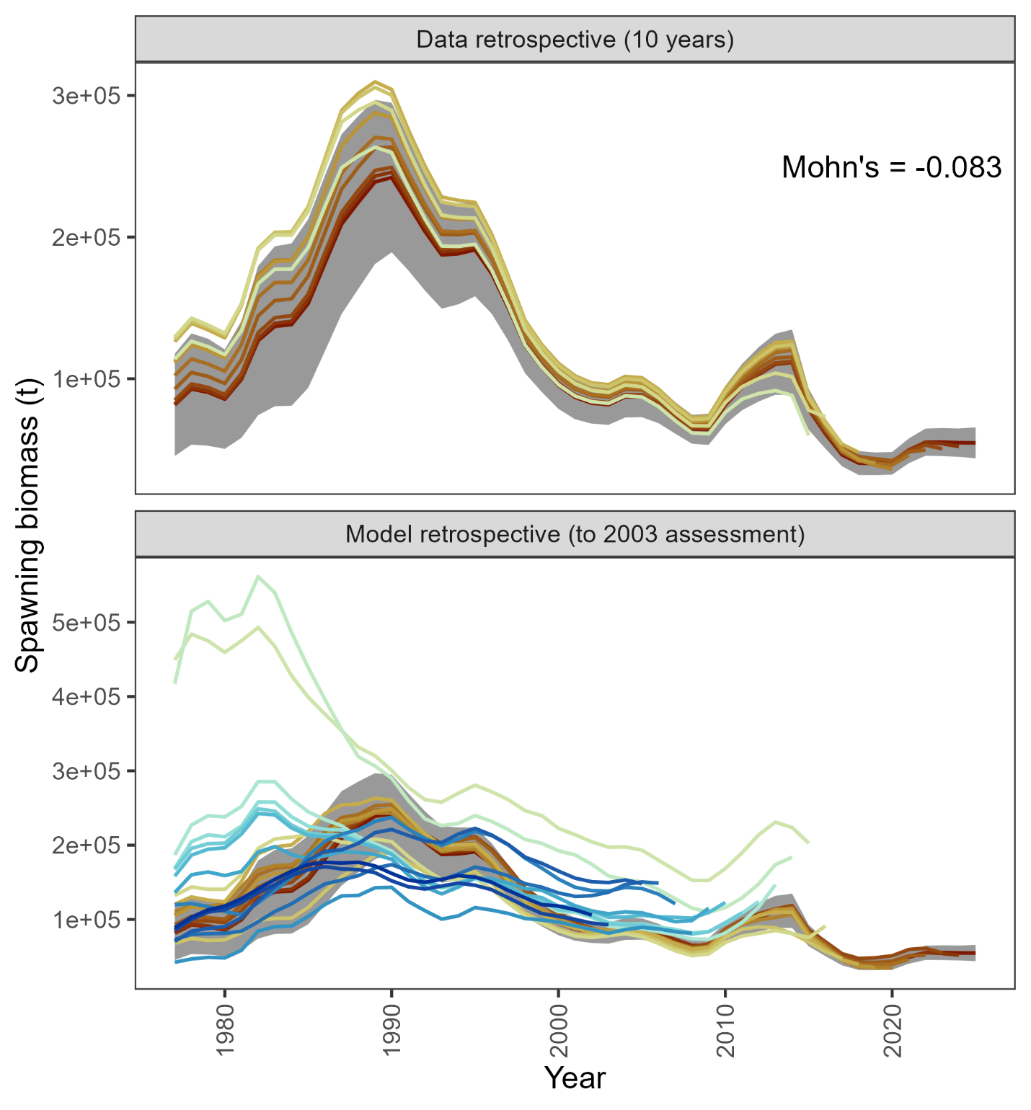

##### Figure 2.9. Retrospective analysis of spawning biomass upon removing data from Model 24.0 (top panel) and in comparison to previously accepted models (bottom panel). The shaded region is the 95% confidence intervals from Model 24.0.

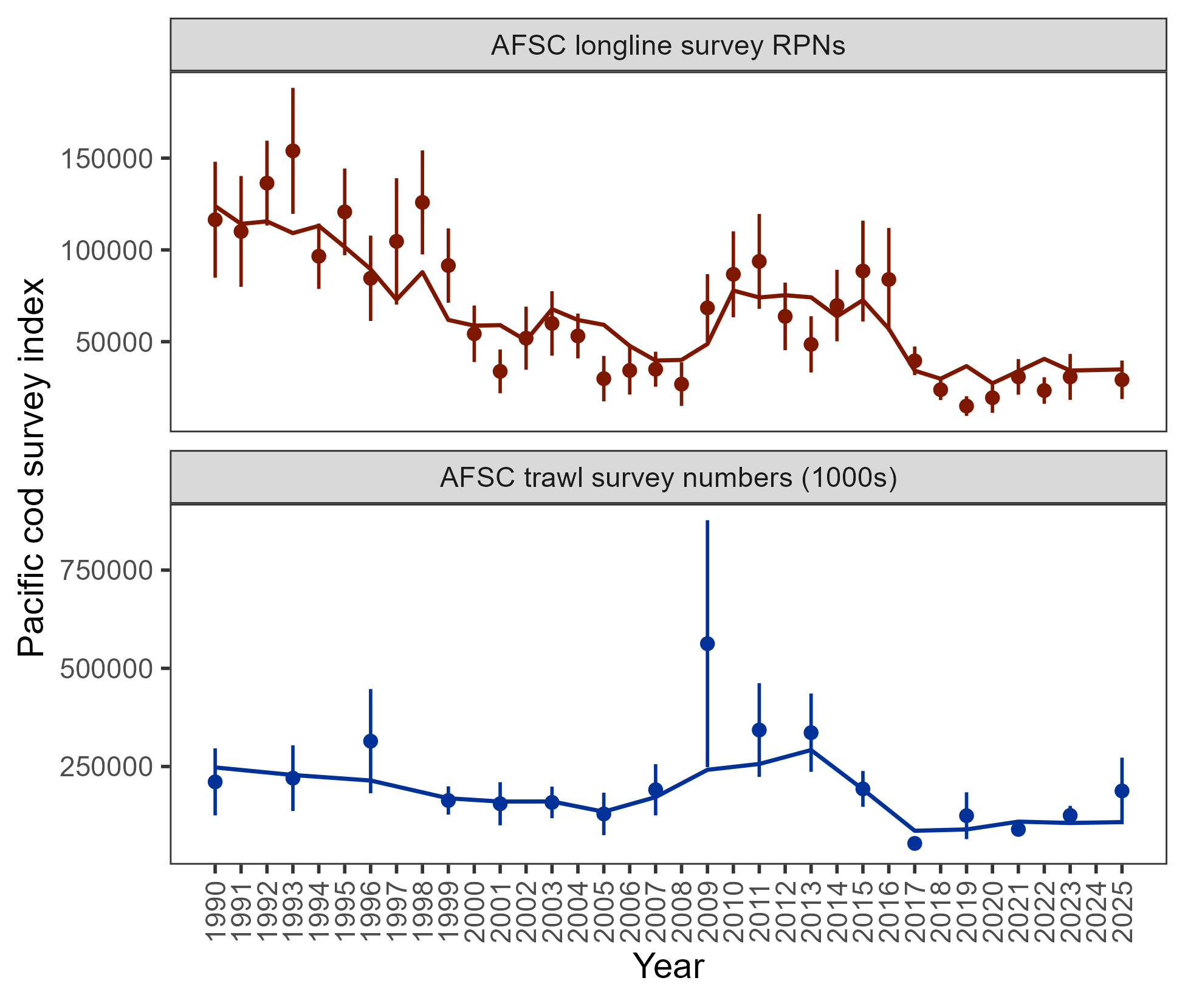

##### Figure 2.10. Population indices fit by the assessment model, including AFSC longline survey relative population numbers (RPN – top panel) and AFSC bottom trawl survey abundance (numbers – bottom panel). Model fit is shown as a solid line and observed data is shown as points (with error bars indicating the 95% confidence intervals).

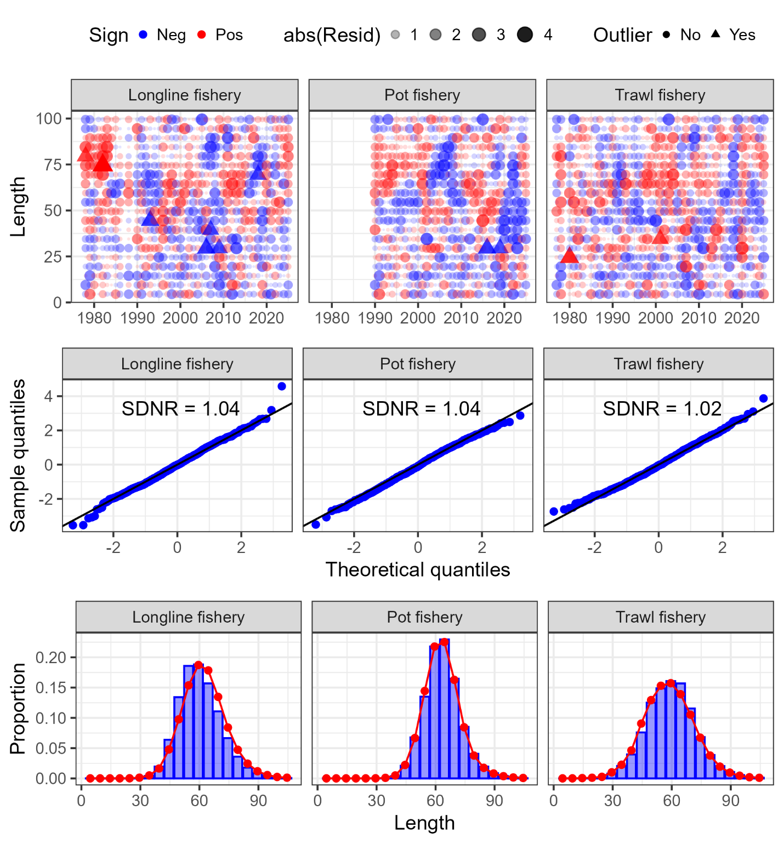

##### Figure 2.11. One-step ahead residuals (top panels), theoretical versus sample quantiles (middle panels), and aggregated model fit (bottom panels) for the fishery length composition data (fleets shown across the columns) fit in the author’s recommended model.

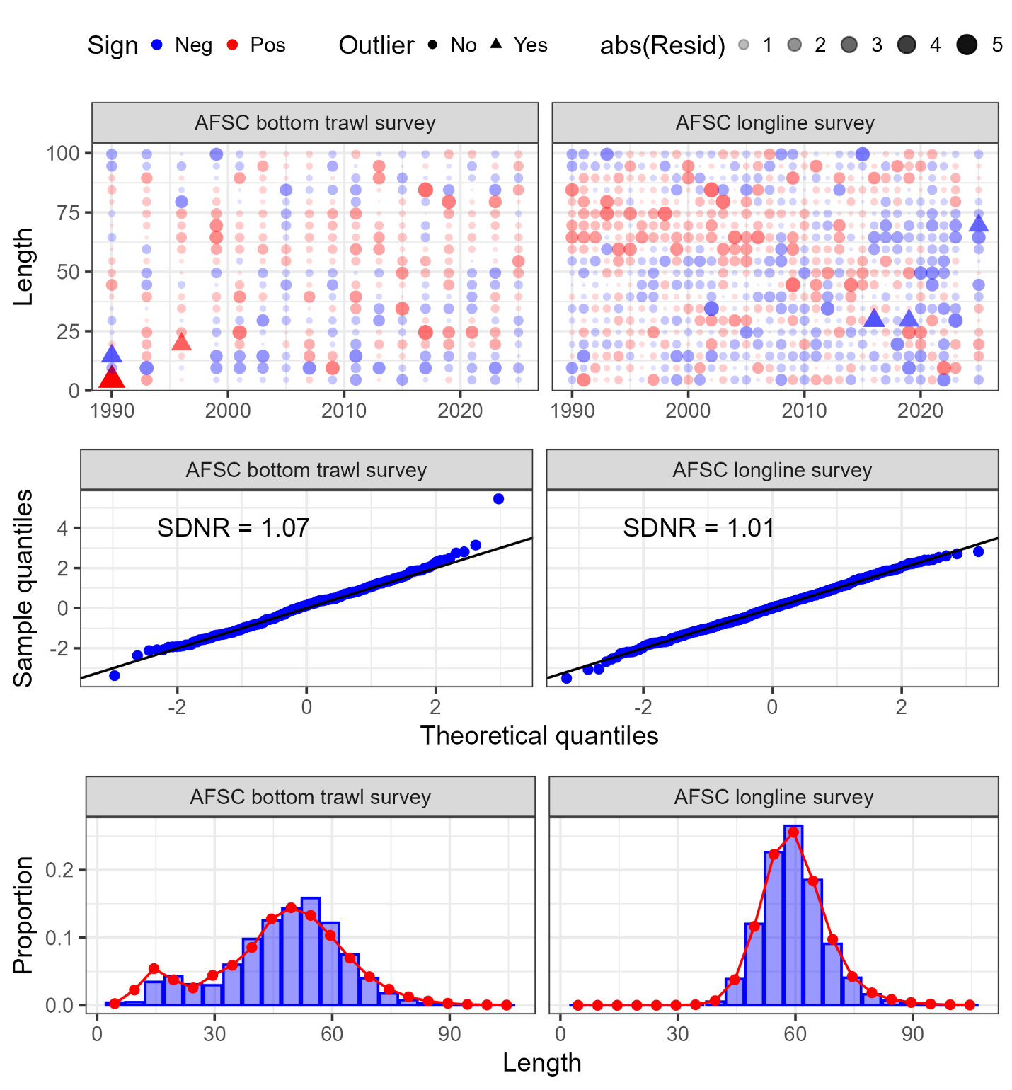

##### Figure 2.12. One-step ahead residuals (top panels), theoretical versus sample quantiles (middle panels), and aggregated model fit (bottom panels) for the survey length composition data (surveys shown across the columns) fit in the author’s recommended model.

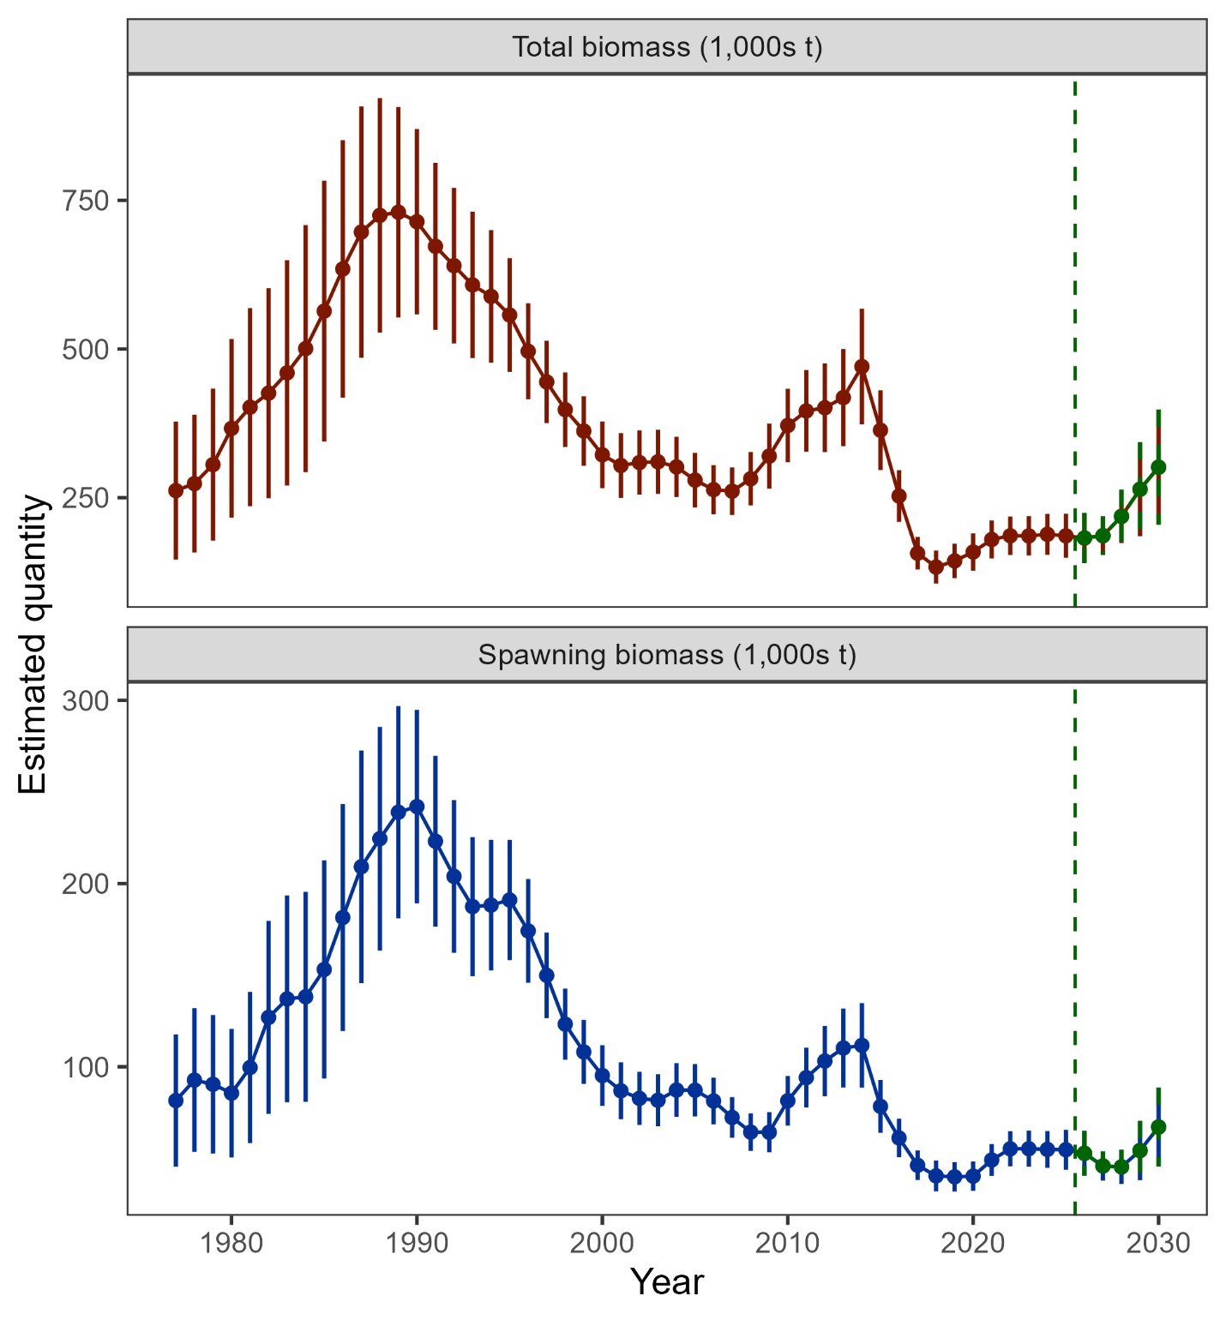

##### Figure 2.13. Estimated total biomass (top panel) and spawning biomass (bottom panel) from the author’s recommended model with 95% confidence intervals. The five-year forecasted biomass values are denoted in green shading and with the vertical dashed line in each plot.

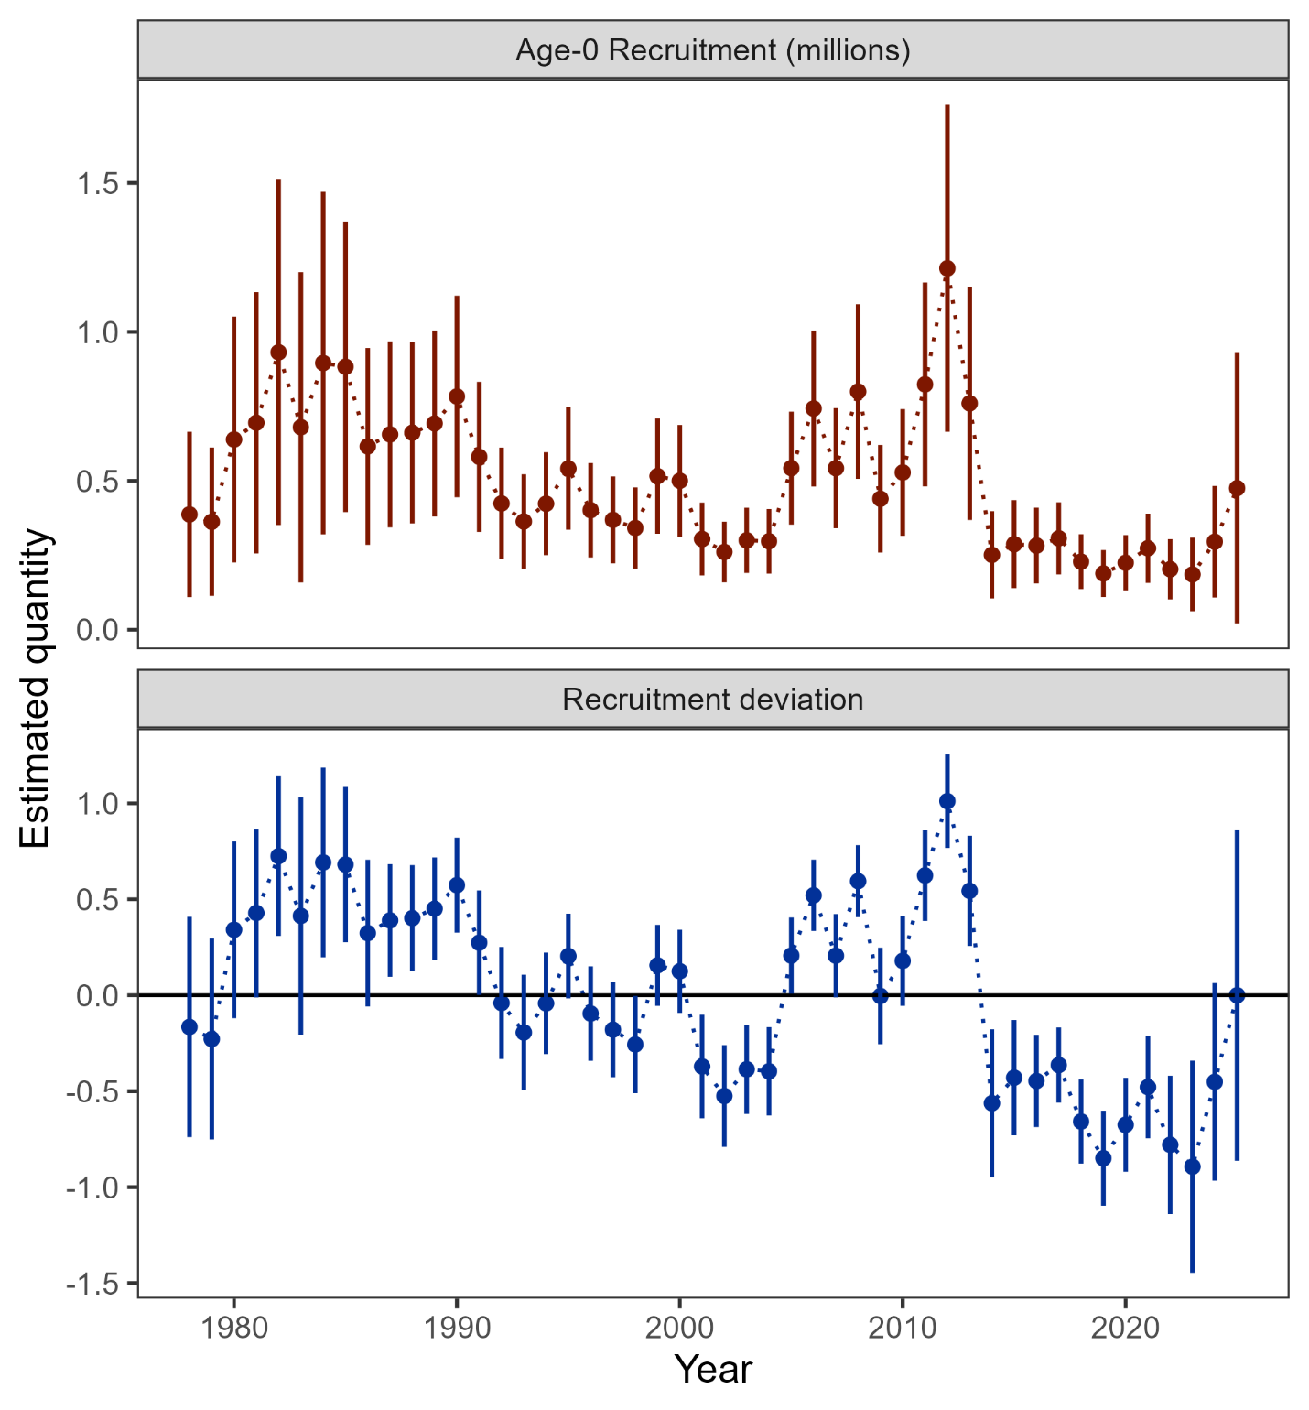

##### Figure 2.14. Age-0 recruitment (top panel) and log recruitment deviations (bottom panel) with 95% confidence intervals from the author’s recommended model.

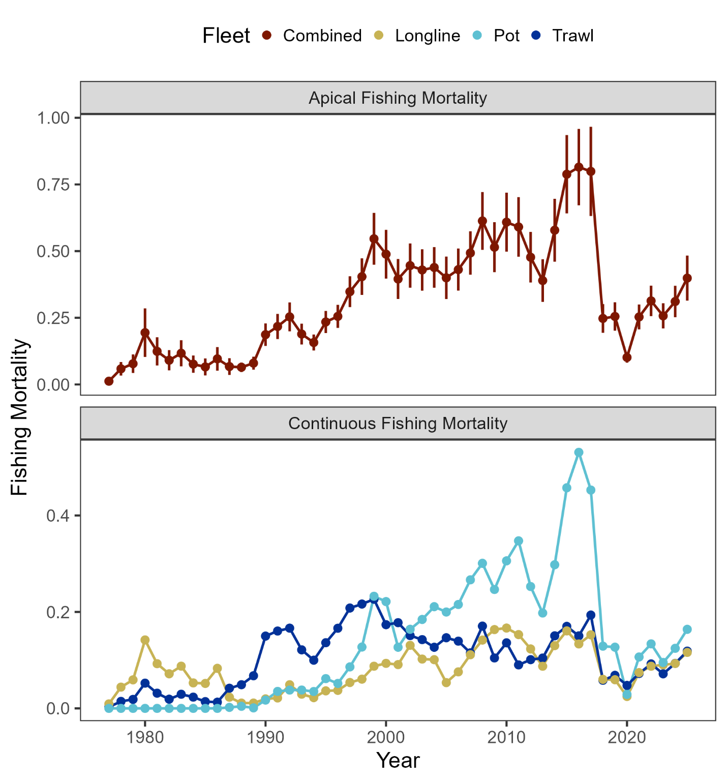

##### Figure 2.15. Sum of apical fishing mortality (top) and continuos fishing mortality by fisheries (bottom) from the author’s recommended model.

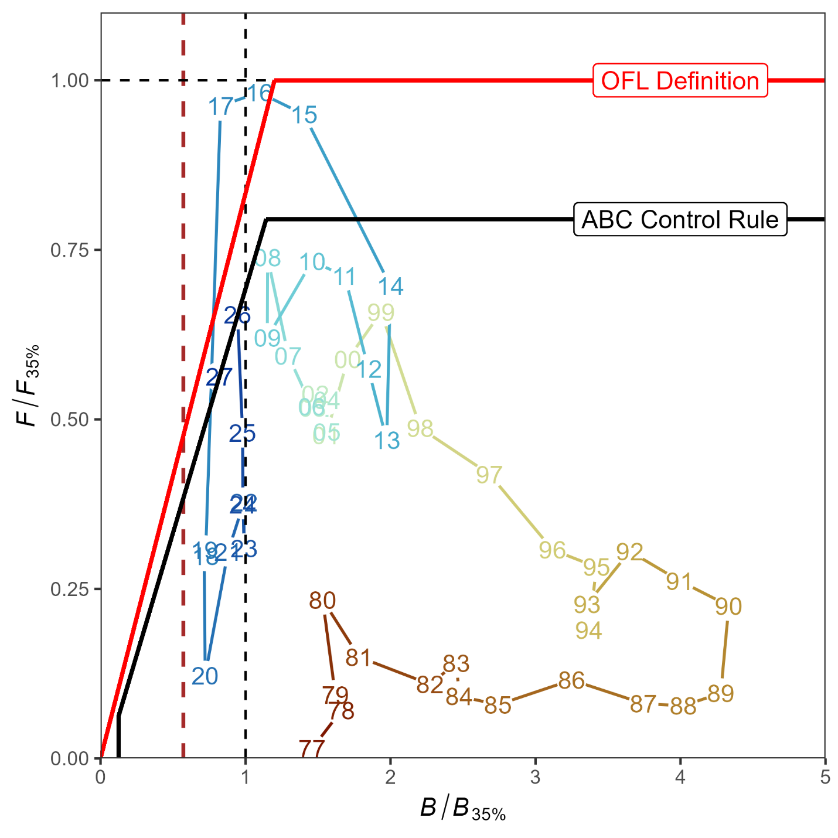

##### Figure 2.16. Ratio of historical *F*/*F35%* versus female spawning biomass relative to *B35%* for GOA pacific cod, 1977-2027 from the author’s recommended model. The Fs presented are the sum of the full Fs across fleets. Dashed vertical red line is at B*20%*, Steller sea lion closure rule for GOA Pacific cod.

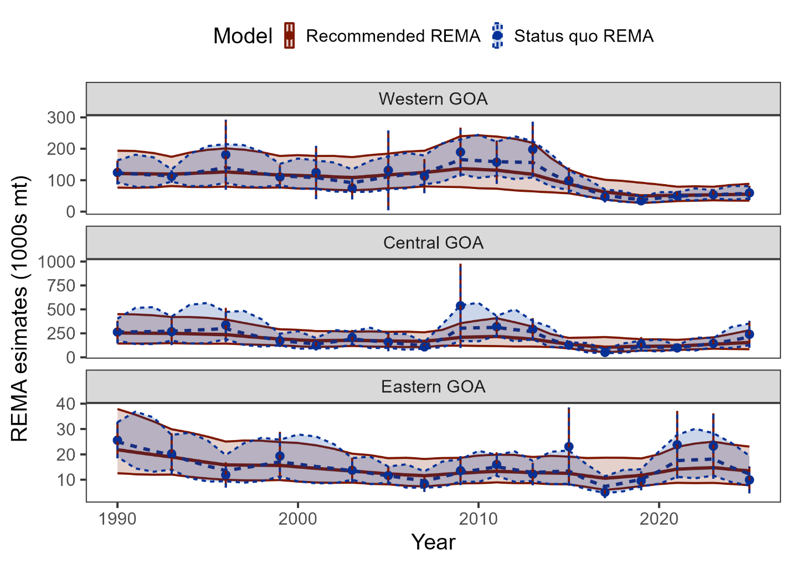

##### Figure 2.17. Recommended and status quo REMA results as fit to the AFSC bottom trawl survey by area.

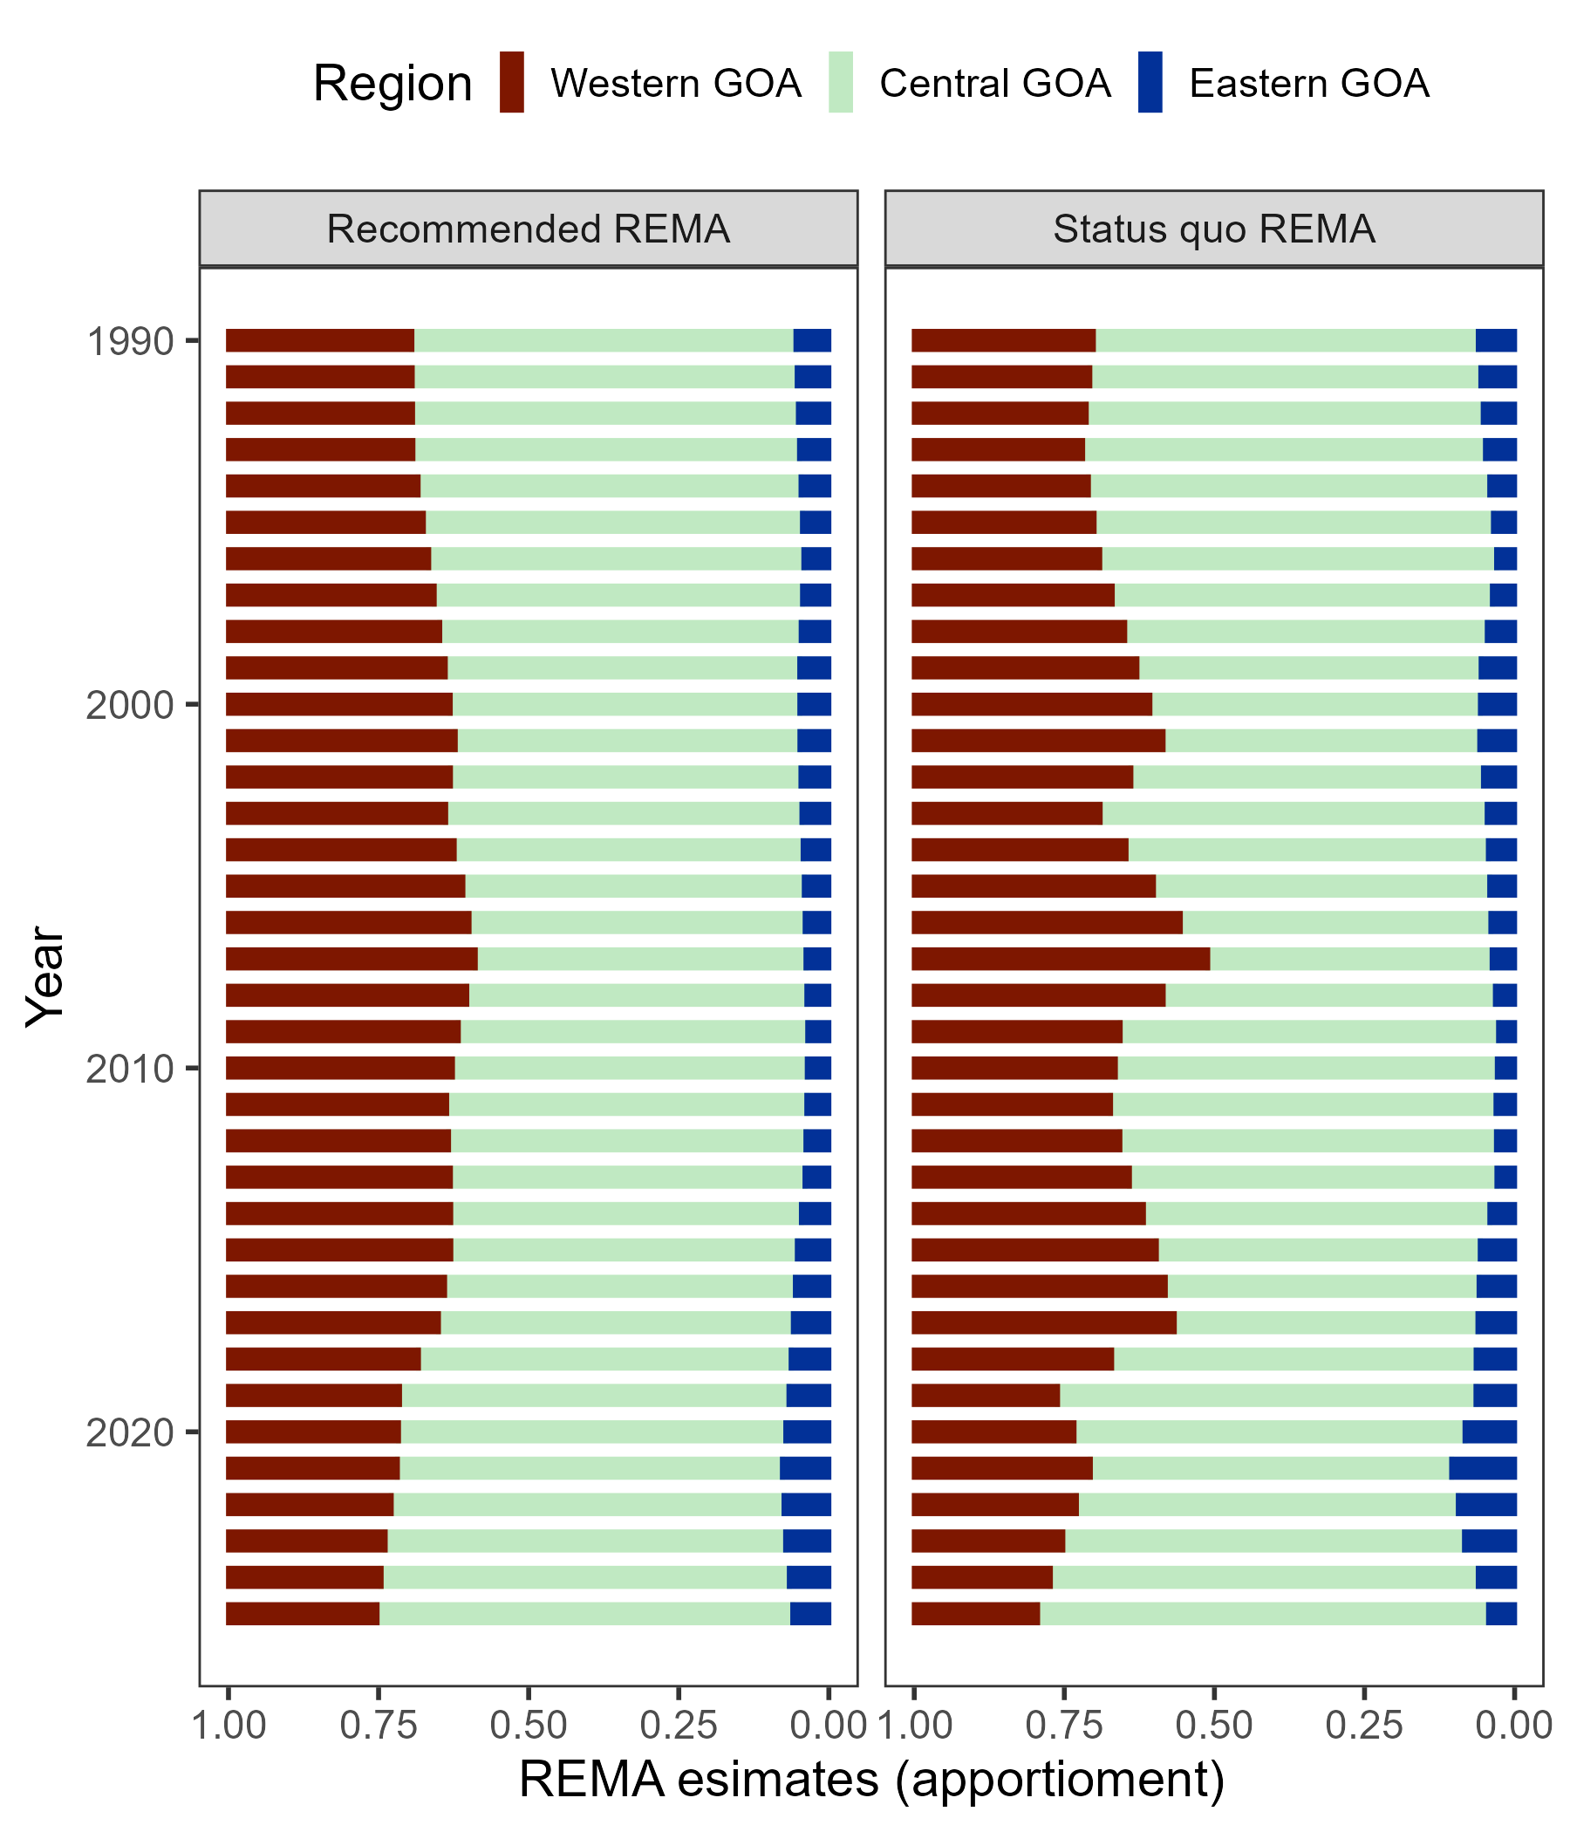

##### Figure 2.18. Recommended and status quo REMA apportionment results.